Court File: T-1450-15

FEDERAL COURT OF CANADA

BETWEEN:

Radu Hociung

Plaintiff

and

Minister of Public Safety and Emergency Preparedness

and

Canada Border Services Agency

and

Her Majesty the Queen in Right of Canada

Defendants

RESPONDING MOTION RECORD

DEFENDANT'S MOTION FOR SUMMARY JUDGEMENT

Radu Hociung

246 Southwood Drive

Kitchener, Ontario

N2E 2B1

Tel: (519) 883-8454

Fax: (226) 336-8327

email: radu.cbsa@ohmi.org

TO:

The Registrar

Federal Court of Canada

180 Queen Street West

Suite 200

Toronto, Ontario

M5V 3L6

AND TO:

Eric Peterson, Counsel to the Defendant

DEPARTMENT OF JUSTICE

Ontario Regional Office

The Exchange Tower

130 King St. West

Suite 3400, Box 36

Toronto, Ontario

AND TO:

Deputy Attorney General of Canada
284 Wellington Street
Ottawa, Ontario K1A 0H8

INDEX

TAB 1 9

Coins not subject to Customs Act provisions 10

Fraud And Threats Committed by BSO Debski 12

CBSA's Bulletin is a recipe for money laundering 14

Fraudulent use of “TEPS” software 16

Gold is Money 18

Other CBSA practices that facilitate money laundering 20

Effects of CBSA's money laundering initiatives 22

Nawaya Case 22

The UM Financial case 24

$2 Coffee Argument 26

Circulation, collector status not affecting currency status 28

Value of gold and siver currency 29

US Code does not say non-circulation 30

CBSA facilitating currency counterfeiting 30

Amateur, Expert and Professional levels of money-laundering 31

Security Context 33

Cui Bono? 34

Why? 35

CBSA is a criminal organization facilitating money laundering. 36

Money Laundering claims agains Christopher Debski 36

Claims against Ann Kendall 37

Claims against Martine Gagnon 40

Claims against Jeffrey Strickland 42

Claims against Joanne Lepage 43

TAB 2 44

CBSA Seizure Receipt 44

TAB 3 45

Online rating for gold coins 45

TAB 4 46

Minister's Decision 46

TAB 5 47

Excise Tax Act sections 50(1)(a), 50(1)(b) and 51 47

TAB 6 48

Excise Tax Act Schedule III Part XI 48

TAB 7 49

Excise Tax Act, section 123(1) definitions 49

TAB 8 50

Canada Revenue Agency Memo 17.1 (Definition of “Financial Instrument”) 50

TAB 9 51

Non-Taxable Imported Goods (GST/HST) Regulations 51

TAB 10 52

Currency Act, s.7-8, 11, 15, 17, 21 52

TAB 11 53

Currency Act, s.17 (2002-12-31 to 2005-12-29) 53

TAB 12 54

Royal Canadian Mint Act 54

TAB 13 55

United States Title 31 55

TAB 14 56

Criminal Code, s380, 469, 467 56

TAB 15 57

European Commission List of Investment gold coins 57

TAB 16 59

CBC article on the retiring of the $1000 banknote. 59

TAB 17 60

National Post Article “The hunt for Canada's $1000 bills” 60

TAB 18 61

Officer Debski Narrative Report 61

TAB 19 63

Evidence taken by officer Debski, photos, photocopies 63

TAB 20 64

Discovery of the Defendant, written answers part 1 64

TAB 21 65

Plaintiff Oral Discovery Examination 65

TAB 22 66

CBSA Customs Officer's Manual, PCMLTFA procedures. 66

TAB 23 67

CBSA Annual Report, 2014-2015 67

TAB 24 68

CBSA Memo 17-1-5 68

TAB 25 69

CBSA Memo D6-2-6 “Refund of Duties and Taxes on Non-commercial Importations” 69

TAB 26 70

Counterfeit gold coins ad from aliexpress.com 70

TAB 27 71

R. v. Nawaya BCSC-179965 71

TAB 28 72

Money Laundering and Terrorist Financing Trends in FINTRAC Cases Disclosed Between 2007 and 2011 72

TAB 29 73

CBSA Travellers Entry Processing System (TEPS) description 73

TAB 30 74

Customs Tariff 74

TAB 31 75

Industry Canada HS490700 exports, imports 75

TAB 32 76

Canada Exchange Fund Account – Annual Report March 31, 2015 76

TAB 33 77

Bank Act, s. 600, 628 77

TAB 34 78

Canada Border Services Agency Act, s15.1 78

TAB 35 79

Financial Administration Act, s.150 79

TAB 36 80

Superintendent of Financial Institutions Consolidated Balance Sheet reporting requirements 80

TAB 37 81

Bombay Jewellers Ltd. v. The Queen, 1998 CanLII 320 (TCC) 81

TAB 38 82

Bank offerings of gold and silver 82

TAB 39 83

Central 1 Credit Union v. UM Financial Inc., 2012 ONSC 889 83

TAB 40 84

RCMP Charges in UM Financial Investigation 84

TAB 41 85

R. v. Kalair, 2015 ONSC 6784 motion 85

TAB 42 86

CBC Story about Khaled Nawaya arrest. 86

TAB 43 87

CBC report about Nawaya freed, gold returned. 87

TAB 44 88

Seizure Report of CBSA for Nawaya gold coins (October 6, 2009) 88

TAB 45 89

Narrative report of seizing officer in Nawaya case (October 6, 2009) 89

TAB 46 90

Canada Gazette – SOR/93-106 “Proclamation Authorizing the Issue and Prescribing the Composition, Dimensions and Designs of Certain Precious Metal Coins” 90

TAB 47 91

Canada Gazette SOR/2012-126 “Order Authorizing the Issue of Circulation Coins of Two Dollars, One Dollar and Twenty-five cents, Specifying Their Characteristics and Determining Their Design” 91

TAB 48 92

Ebay completed auction for 8 “war of 1812” quarters 92

TAB 49 93

Admasu v. Canada 2012 FC 451 93

TAB 50 94

Sellathurai v Canada (Minister of Public Safety and Emergency Preparedness), 2008 FCA 255 94

Sellathurai v. Canada (Public Safety and Emergency Preparedness), 2007 FC 208 94

TAB 51 95

Forum posts about CBSA's treatment of gold as 'goods' 95

TAB 52 96

Zakir Naik ban from Canada, UK, Bangladesh and India 96

TAB 53 97

Joanne Lepage assurances to Livingston Consulting 97

TAB 54 98

Seizure synopsys 98

TAB 55 99

Electronic Enforcement Appeal Form 99

TAB 56 100

Canada Revenue Agency, GST/HST Memo 17.1, “Definition of Financial Instruments” 100

TAB 57 101

CBSA (Ann Kendall) Letter to Radu Hociung dated November 3, 2014 101

TAB 58 102

Plaintiff letter to CBSA, November 10, 2014 102

TAB 59 103

Minister of Finance precious metals coins affidavit 103

TAB 60 104

US Public law 109-145 (Presidential $1 Coin Act of 2005) 104

TAB 61 105

November 19, 2014 advice by CBSA colleagues that gold is goods 105

TAB 62 106

December 11, 2014 Ann Kendall letter to the plaintiff 106

TAB 63 107

December 17, 2014, Notes on telephone conversation between Ms. Ann Kendall and the plaintiff. 107

The plaintiff's notes on the conversations 107

TAB 64 108

TAB 65 109

January 21, 2015 Plaintiff letter to CBSA President. 109

TAB 66 110

Jan 29, 2015 John Dancause letter to Ann Kendall 110

TAB 67 111

March 9, 2015 letter from Martine Gagnon to the plaintiff. 111

TAB 68 112

March 17, 2015 letter from the plaintiff to Ms Gagnon 112

TAB 69 113

May 26, 2015 letter from Ms Gagnon to the plaintiff. 113

TAB 70 114

May 28, 2015 drafted Minister's Decision by Martine Gagnon 114

TAB 71 115

Case Synopsys 115

TAB 72 116

Canada Border Services Agency Act s12 116

TAB 73 117

Blah... 117

Court File: T-1450-15

FEDERAL COURT OF CANADA

BETWEEN:

Radu Hociung

Plaintiff

and

Minister of Public Safety and Emergency Preparedness

and

Canada Border Services Agency

and

Her Majesty the Queen in Right of Canada

Defendants

WRITTEN REPRESENTATIONS OF THE PLAINTIFF

(Defendant's Motion for Summary Judgement)

SUBMISSIONS
- The Defendant's Motion for Summary Judgement, seeking to dismiss the action, is a materrially identical motion to his August 30th 2016 Motion to Strike the Statement of Claim, which was unsuccessful.
- The present motion is unnecessary and vexatious. As a result, the plaintiff seeks that the action be determined on its merits, based on the evidence adduced herein pursuant Federal Court Rule 214, and that costs on the motion be awarded to the plaintiff on a substantial indemnity basis.
- In his Motion to Strike the Statement of Claim, the defendant, proposed, as he does in this motion, that the Currency Act section 8 shows that the coins in question are not currency. As he did on that motion, the plaintiff states that section 8 does not define currency, but rather states how currency, defined in section 7, may be used for payments, and that it explicitly states that coins of denominations $1 and $50 may be used for payments. The Defendant claims that s.8 states the opposite of what it does.
- In her decision on the Motion to Strike, Madam Prothonotary Martha Milczynski, refering to the defendant's claim with respect to Currency Act section 8 noted that the defendant's argument in fact goes to the merits of the case.
- The defendant still makes that claim, and provides no additional evidence in support of his case, and therefore has no reasonable expectation of success on this motion. This motion is therefore unnecessary.
- The motion also comes at a time when discovery of the defendant is still in progress. Discovery started on July 19, 2016, and the defendant had used several delay tactics to avoid discovery: the motion to strike, a 6 month delay, and various improper statements of objection to the questions asked. His delays have forced the plaintiff to request Case Management, which was granted. This motion comes one day prior to a Case Management conference scheduled for March 2nd (TAB 73). The agenda for the March 2nd conference were largely requests by the plaintiff that the defendant be ordered to fully answer the questions asked on July 19, 2016, and to answer the questions arising from the partial answers provided on January 31st, 2017. After filing the motion, the defendant requested from Case Management that discovery be suspended until this motion, and a motion brought by the plaintiff to amend the statement of claim, are determined.
- From the timing of the motion, it is clear that the defendant's purpose is not to have case determined, but to stall discovery and prevent discovery of further evidence. Therefore, his motion is vexatious.

Coins not subject to Customs Act provisions
- The only statute that gives the Customs Act authority to impose, levy and collect taxes and duties on imported goods is the Excise Tax Act (“ETA”) s.50(1) and s50(1)(b) (TAB 5). This section applies only to “goods”, while the coins that make the object of this action and the Minister's Decision are “currency”. Therefore, as the Customs Act does not apply to currency, the Minister's Decision is incorrect and should be set aside.
- Even if the coins were “goods”, ETA s.51 (TAB 5) states that tax imposed by section 50 of that Act does not apply to the importation of goods mentioned in Schedule III, also meaning that section 50(1)(b), which states that the Customs Act governs the paying of import duties, also does not apply to Schedule III goods. (for greater clarity, the Customs Act does not apply to Schedule III goods)
- Schedule III, Part XI of the ETA (TAB 6) lists the following:

3. British and Canadian coins; foreign gold coins

4. Coin of any metal, of authorized weight and design, issued for use as currency under the authority of the government of any country.
- While para 3 of Schedule III Part XI applies to the gold coins in question, para 4 applies equally to the gold and silver coins, having been issued for use as currency under the authority of the United States government (per U.S. Title 31, see TAB 13).
- Schedule III, Part XI makes no reference to the fair market value of any items, thus the “true” or denominated value of coins is of no consequence in the exemption determination.
- Also, ETA section 212 (Importation Tax, TAB 5) does not apply to imported coins because section 212 applies only to persons “liable under the Customs Act”, and the plaintiff is not liable under the Customs Act thanks to section 51 of the ETA. Furthermore, there is an overlapping exemption for the importation of precious metals, in the form of section 213, which states that the tax on importation of goods does not apply to goods listed in Schedule VII of the ETA. Precious metals as defined in s.123 for the ETA are prescribed goods pursuant Schedule VII sec. 8, as prescribed by Non-Taxable Imported Goods (GST/HST) Regulations para 3(a) (TAB 9). The effect is that the importation of coins (precious metal or otherwise) is not subject to the Customs Act at all.
- Thus, the plaintiff was not required to report the coins seized by the CBSA (see Seizure Report, TAB 2) pursuant section 12 of the Customs Act, and the seizure is improper.
- The Minister's Decision supporting the seizure, dated June 1, 2015 (TAB 4) should therefore be set aside.
- In fact, not only is the Minister's Decision wrong, it is so wrong that using it as an excuse to avoid reporting requirements pursuant the Proceeds of Crime (Money Laundering) and Terrorist Financing Act (“PCMLTFA”) s. 12 is a crime, and an offence contrary to section 74 of the PCMLTFA, as found in Canada v. Nawaya, BC Provincial Court case 179965 (TAB 26), which finds gold coins to be currency or monetary instruments, and subject to the PCMLTFA.

Fraud And Threats Committed by BSO Debski
- In his narrative report, written at the time of seizure (see TAB 17), officer Debski indicated his understanding that the coins in question were “technically currency”, but went on to explain he would not be treating them as such.
- While he understood that the coins were currency, during the conversation with the plaintiff, he insisted that they were “goods” subject to reporting under the Customs Act.
- As he understood the coins were currency, the officer conducted a search of the plaintiff's wallet, looking for more currency, in the hope that he would find a total of over $10,000, which would have allowed him to confiscate it all pursuant the Proceeeds of Crime (Money Laundering) and Terrorist Financing Act (“PCMLTFA”) - see copy of the plaintiff's Citizenship card (TAB 18), which the plaintiff keeps in his wallet. The officer stated in his narrative report that he only requested the plaintiff's keys, passport, driver's licence, ownership and the gold coins (TAB 17, page 2, para 3), but the fact that he also made a copy of the Citizenship Card proves he requested and searched the wallet.
- The officer asked a further question, betraying that he was of the mind that he was dealing with currency rather than goods. He asked “Where do you have so much money from”, (TAB 19, question 20). This is clearly a question of provenance of funds, (see CBSA Customs Officer's Enforcement Manual, TAB 21, para XXX). This question is not relevant for Customs Act purposes, ie, the Customs Act is not concerned with how goods were purchased, but it is relevant to for PCMLTFA purposes to assess whether there is reason to suspect the money may be the proceeds of crime (see TAB 21, CBSA PCMLTFA enforcement manual, para 85), instructing that the officer must gather reasonable grounds to suspect, in support of a seizure with no terms of release. The officer admitted in response 20 of the Discovery of the Defendant (see TAB 19, answer 20) that the question was not pertinent to the seizure action, which was a Customs Act seizure, leaving the PCMLTFA as the only other Act to which the question was pertinent.
- As the officer was unable to establish grounds to suspect the gold and silver coins proceeds of crime, nor that the prescribed $10000 amount had been exceeded, he proceeded to seize them as “goods” explaining that they had not been reported as the Customs Act section 12 requires.
- He threatened the plaintiff with arrest (an act of violence), stating that smuggling was an arrestable offence (answer 7 of Discovery of the Defendant Answers, TAB 19), in supporting his request that the plaintiff give him the gold and silver coins.
- The officer's behaviour was offensive and threatening, starting with his initial greeting “What do we have here?”, in a schoolyard bully tone, to his posturing, showing readiness to use his weapon, to yelling orders at the plaintiff (see Discovery of the Plaintiff, at answers 57, 65-72), in supporting his request that the plaintiff give him the gold and silver coins.
- The plaintiff feared for his safety and did not wish to be shot at or arrested, so he handed the coins to officer Debski.
- In his narrative report officer Debski listed the criteria used by Canada Revenue Agency to identify financial instruments (see CRA policy P-192 in TAB 8, paras 3, 27-28) writing “Only those coins minted with metals at the required purity levels and issued by a government authority qualify” (TAB 17, page 2, para 4).
- While the document that officer Debski quoted in his narrative report reads “... issued by a government authority and that may be used as currency will qualify”, the officer purposely left out the words “that may be used as currency” from his narrative, in order to support his assertion that these coins are “goods”.
- He did not tell the plaintiff about the definition of financial instruments he was using, but proceeded to prepare the Seizure Receipt (TAB 2), in which he used the words “United States of America $50; 1oz of .9999 Fine Gold Coin” and “United States of America Silver Dollar, 1oz. Fine Silver”, showing both that they were above issued by the United States Government, and that the purity of the metal was at the required purity levels, as listed by the Excise Tax Act s.123(1) definition of financial instruments (precious metals) (TAB 7).
- While the purity of the silver coins is not shown on the coins due to space constraints, a lookup on the United States Mint would reveal the specifications of the coins, and its silver content of 99.9% (ie meeting the purity requirement).
- The officer's false representation that the coins were subject to reporting under the Customs Act also helped induce the plaintiff into handing over the coins. The plaintiff was not entirely convinced that he should have reported them, however, the officer explanation that they had been “purchased” outside of Canada, therefore were “goods” did make some sense (officer's narrative report, TAB 17)
- The seizure of the coins resulted in a loss of $6427.89 by the plaintiff to the CBSA (see seizure report, TAB 2)
- Even if the coins would be ultimately returned, the officer would still gain the amount of the terms of release on behalf of the CBSA (in this case the officer had set a 25% amount, or $1606.97). This represents the benefit that the CBSA would have obtained as a result of the fraud, but the amount of $6427.89 was the amount the plaintiff was deprived of.
- Thus, officer Debski has committed fraud over $5000 as described by the Criminal Code section 380.

CBSA's Bulletin is a recipe for money laundering
- In his decision to seize the coins, officer Debski admitted in his narrative report (TAB 17, page 2, para 4) that he was aided by a secret internal bulletin circulated within the CBSA, the “Information Bulletin – Precious Metals – Bullion and Coin” (“the bulletin”, attachment in TAB 19).
- The bulletin acknowledges in the first paragraph/abstract that it gold and silver are “investment metals”.
- While the bulletin is titled “Information Bulletin”, it contains no references to specific Acts of Parliament and sections to which it refers, so the information contained within it cannot be verified, as the context of the statements it makes cannot be ascertained.
- Further, in the abstract (page 1, para 2), the bulletin states that a Cross-Border Currency or Monetary Instrument report is not required to be filed for precious metal importation.
- The bulletin, at para 4 quotes the definition of “financial instruments (precious metals)” from the ETA s.123(1) (TAB 7), and for further clarity, at para 5 it quotes the Canada Revenue Agency policy P-192 (TAB 8, paras 28-30), which is part of CRA's Memo 17.1, titled “Definition of 'Financial Instrument'”. The sole goal of the CRA memo is to clarify the ETA's provisions with respect to Financial Instruments.
- Further in paras 7-10, the bulletin shows examples of Financial Instruments (precious metals), and lists various identifying criteria. It even depicts a Canadian $50 gold coin (ie, Canadian currency per the Currency Act), a silver bullion bar, a Royal Canadian Mint gold ingot and a Credit Suisse platinum waver.
- On page 2, para 4, the bulletin states “Coins are also to be treated as goods and not as currency”. (The word “not” is underlined in the bulletin).
- Then it proceeds to explain that the coins have legal tender status, but the face value is “purely symbolic”, which is the opposite of what the Currency Act, s.7 (TAB 10) which states “A coin is current for the amount of its denomination in the currency of Canada”, ie, that the denomination is the value of the coin. (In Canada, the value of currency is set by decree, which is s.7 of the Currency Act).
- In fact, the defendant understands that the “symbolic value” argument is not true, and he gives an example that is addressed at para Error: Reference source not found Error: Reference source not found.
- Further on page 2, para 4, advises that financial instruments in gold or silver bar, ingot or wafer forms are also to be treated as goods, and not reported pursuant the Cross-Border Currency or Monetary Instruments Regulation. Once again, the bulletin emphasized the word “not”.
- Further, on page 3, the bulletin outlines a method for generating “terms of release” revenue for the CBSA, by using the Travelers Entry Processing System (TEPS) software. The “penalty” is to be assessed of persons who refuse to declare financial instruments (precious metals) and currency as “goods”.
- Together, the advice of treating financial instruments and gold/silver currency as “goods” and not reporting them pursuant the PCMLTFA constitute a money laundering facilitation method.
- While the bulletin advises border officers that they override the TEPS software's determination of 13% GST/HST with a 0% value, it is clear that officers have the ability discretion to not do so. In the seizure that is the object of this action, officer Debski clearly did not override the TEPS software.
- In many cases travellers are aware of the CBSA's treatment of financial instruments or are informed by the CBSA officers, resulting in a GST/HST payment of 13% to the CBSA. In the present action, if the plaintiff had declared the gold currency as “goods”, he would have been charged 13% (as evidenced by both the seizure report, TAB 2 and the separate online rating generated by the CBSA at the time of enforcement, TAB 3).
- The tax payment can be made in cash at the CBSA's cashier counter. Given that this payment takes place before a traveller is required to report currency imported into Canada, and also since the tax payment is not in fact imported into Canada, the cash used for the tax payment can be “dirty”, ie proceeds of crime, that goes undetected, unreported to FINTRAC.
- The CBSA operates a program for refunding duties and taxes on “non-commercial importations” (TAB 24), by which duties paid in error due to determination are refunded to travellers upon submission of documentation that the gold/silver imported should have been treated as tax free, as the bulletin shows. As a result, the CBSA refunds the tax paid in error by mailing to the traveller a Government of Canada cheque for the tax paid.
- By using the tax refund mechanism, the CBSA offers a service by which it takes “dirty” cash as a tax payment, and later refunds it as a “clean” government cheque. This process of inserting the proceeds of crime into the banking system, is by definition, money laundering.
- Therefore , not only does the CBSA facilitate money laundering by treating financial instruments (precious metals) as “not subject to the PCMLTFA”, but also launders money by taking dirty cash as “taxes”, and refunding it as “clean” government cheque.

- The bulletin contains a footer on every page stating: “ PROTECTED - This document is the property of the CANADA BORDER SERVICES AGENCY. It is provided on the understanding that it will be used solely for official purposes by your agency and that it will not be further disseminated without the written permission of the CANADA BORDER SERVICES AGENCY”
- In light of the illegal instructions contained in the bulletin, the secrecy of the document is indended to shield the CBSA from becoming the target of legal action, and also from becoming the target of the “War on Terror”, “War on Drugs” and various similar “wars”.
- Based on the annual reports of the Royal Canadian Mint, and by statistics from Industry Canada regarding the importation of gold coins under the tariff, it appears that the majority of 1oz gold coins produced by the Royal Canadian Mint are exported and accounted by the CBSA as goods, under the tariff 7118.90.00.10, as recommended by the bulletin. Presently this amounts to approx $1.8 billion annually. The CBSA has refused to provide evidence to establish the amount of financial instruments treated as gold (discovery questions 1-4, TAB 19), and thus the statistics from the government sources are the best evidence.

Fraudulent use of “TEPS” software
- The bulletin also instructs officers to use the TEPS software to obtain “terms of release” payments for currency and financial instruments which are exempt from provisions of the Customs Act.
- The software, used by the CBSA at ports of entry is used to determine the duties and taxes owing on imported goods (Discovery of the Defendant, TAB 19, question 23).
- On CBSA's own website (TAB 28, page 45), the software's purpose is stated to be: “TEPS Assists the Border Service Officers in the assessment and collection of duties, taxes and other relevant data on travellers' importations.”
- In the defendant's answer to discovery, question 23, the defendant admits that the coins were determined to be “tax exempt”, but rather than also conclude that the TEPS software should have not been used at all, it concludes that the terms of release were incorrectly calculated.
- As shown before, as the coins in question are not “goods”, but currency, they are not subject to taxation under Excise Tax Act s.50(1) (TAB 5), and therefore also not subject to the provisions of the Customs Act stipulated by s.50(1)(b). Even if they were somehow considered “goods”, they would be exempt from s.50 by virtue of the examption given in s.51 and Schedule III, Part XI, items (3) and (4). As such, there is no collection of duties or taxes that the Border Service Officers would need assistance with.
- The TEPS software is little more than a glorified calculator, in that it looks up tax rates in tables, stores statistics of all goods imported nation wide. It is not however intended to determine exemptions, which are the responsibility of the officers. Ie, the officers should first determine if an item is a “good”, if it is “imported”, and if it is not exempted by ETA s.51, and only if these criteria are met, then the TEPS software should be used to assist with the calculation of duties and tax. For example, one would not enter “banknotes” into the software, under the tariff 4907.00.00.12 (Banknotes being legal tender, issued, see Customs Tariff, TAB 29), unless the traveller reporting them were someone like the Canadian Bank Note Company, as none of the HS4907 items are “goods” as per the intent of the Excise Tax Act (they are all things like money or financial instruments).
- In fact, statistics from Industry Canada (TAB 30) show that the CBSA also classifies importation of banknotes and other money-like things under the tariff heading HS4907, however not enough detail is available to ascertain if the statistics refer to “issued” or “non-issued” such items. “Issued” banknotes would of course be financial instruments, while “non-issued”, such as banknotes printed by the Canadian Bank Note Company, and shipped to a foreign central bank for issuance would be “goods”.
- The defendant's position is however that all coins or banknotes can be classified under some heading of the Customs Tariff, they can be treated as “goods”, and the TEPS can be used to extract “terms of release” payments, and even more seriously, such banknotes and coins would not be subject to the PCMLTFA.
- Certainly the defendant makes the case that “collectible” or “non-circulation” money is “goods”, which is wrong.

Gold is Money
- Excepting products made from gold, like jewellery, whenever Canada's legislation mentions “gold”, it is in a “money” context. In fact, there is no support to the CBSA's claim that precious metal in bar, ingot, wafer or coin form is “goods”.
- While coins made of gold under the Royal Canadian Mint Act, are “currency”, respecting Currency Act s.7-8, they are not are not “gold” as they cannot be melted or used in any other way than currency (such as to manufacture gold jewellery), as this is prohibited by s.11 of the Currency Act. In any case, they are not referred to as “gold”, but as “currency” in legislation.
- The Currency Act, s.15 (TAB 10) provides that gold is a type of currency, similar to “a currency of a country other than Canada” or “a unit of account that is defined in terms of two or more countries” (making reference to the SDR, which is issued by the IMF as a “basket of currencies”), but as it is an universal currency, and not any one country's currency, it is listed separately.
- s.15 of the Currency Act provides that the Governor in Council may make regulations that specifies the equivalent dollar value of those currencies or gold. This acknowledges the equivalency of currency with gold.
- In fact, the purpose of s.15 is to enable Canada to unilaterally default on any treaty, convention, contract or agreement, by permitting the Governor in Council to declare a means of calculating the equivalent value in ways different than the universally accepted fair-market exchange rates. The Governor in Council has indeed used this facility to default on previous agreement, with the Canada Shipping Act Gold Franc Conversion Regulations, and the Carriage by Air Act Gold Franc Conversion Regulations, which set the conversion value of gold to approx $12.81 per troy ounce of gold, while the fair-market value is presently about $1640
- s.15 does not say that the Governor in Council is to make such regulations for all of Canada's contracts, nor does it say anything about provincial or private contracts, which remain payable in gold if they were so entered into, in other words, gold remains a recognized international currency.
- The Excise Tax Act s.123(1) (TAB 7) defines Financial instruments to be among other things, “precious metals”, defined as bars, ingots, coins or wafers of gold, silver or platinum, refined to minimum purity levels of at least 99.5% for gold and platinum, and 99.9% for silver. In other words, gold is money (a financial instrument).
- Further, the Currency Act, in reference to the Exchange Fund Account, in the version pre-dating 2012-12-29, (TAB 11), section 17 specifically named gold as an asset that the Finance Minister may transact in for the purposes of the Exchange Fund Account, in addition to other currencies designated by the Minister. After 2012-12-29, the Currency Act was amended to replace section 17 with a section that does not explicitly state what assets the Exchange Fund Account may hold, nor how the Minister may transact, but instead leaving those decisions up to the Minister. (see the current section 17 in TAB 10). Thus, with respect to the Exchange Fund Account, gold is a currency.
- In section 21 of the Currency Act, the Finance Minister is directed to table a report on the operation of the Exchange Fund Account on a yearly basis. That report shows gold as an International Reserve held in the Exchange Fund Account, along side US dollars, Euro, British pound sterling, Japanese yen, Special Drawing rights in cash, cash equivalent and securities forms (see TAB 31). Therefore, gold is a currency.
- Pursuant sections 600 and 628 of the Bank Act (TAB 32), all deposit taking institutions operating in Canada must provide the Superintendent of the Financial Institution with a monthly consolidated balance sheet report, which is to comply with instructions given by the Superintendent (TAB 35). This required balance sheet, is to contain, in the Assets section, subsection “A1 Cash and Cash equivalents”, a report of gold coin, gold and silver bullion, gold and silver certificates, precious metals, Bank of Canada notes on hand, etc. It is significant to notice that the first four items required to be included as Cash and Cash Equivalent Assets are gold and silver is several forms, ahead of bank notes, or other coins and completed deposits. This shows that not only that gold is a currency (cash and cash equivalent), but it is more important than other forms of assets (the list is shown not in alphabetical order, but in the order of importance).
- In Canada v. Nawaya, BC Provincial Court case 179965 (TAB 26), the Crown (information by RCMP) argued that Canadian $50 gold coins were currency. In this case, it is not in fact the metal, but the token aspect of the coin that makes them currency. This argument was successful.
- In Bombay Jewellers Ltd. v. The Queen, 1998 CanLII 320 (TCC) (TAB 36, para 24), Margeson, J.T.C.C., the Crown argued that gold and silver bars, bearing a weight, purity and manufacturer mark are financial instruments. This argument was successful, though many arguments by both parties in this case were flawed, which lead to a decision in favour of the respondent. Nonetheless, the judge accepted the argument about markings defining a gold bar as financial instrument.
- Banks deal exclusively in money-like products (cash, loans, savings, investments, insurance, etc). One of their investment offerings is gold, in various forms (though not jewellery, which is “goods”). They buy and sell gold in financial instrument form, as admitted in Bombay Jewellers Ltd. v. The Queen, and evidenced by the online websites of TD Canada Trust and Bank of Nova Scotia (TAB 37).
- A person can purchase gold from one bank, then sell it to another, in effect moving money from one account to another. Banknotes can achieve the same feat, but in a more limited way. Eg, an account liquidated in Canada in the form of Canadian banknotes cannot be easily deposited with a bank in another country, like Egypt, and vice versa. Not only is gold a cash-equivalent, it is a much better form of cash than banknotes.
- In fact, in Central 1 Credit Union v. UM Financial Inc., 2012 ONSC 889 (TAB 38), the defendant purchased $1.867 million worth of gold bars from Bank of Nova Scotia with funds from the debtor's bank account. Then he hired a Joseph Adam to physically transport the gold to Egypt to pay “shariah consulting services” who had provided advice from 2004 to 2011. An invoice was even created by UM Financial in the amount of $2,790,000 for the services. In this case, the defendant was clearly paying an invoice in gold, further evidencing gold's use as money. In relation to this case, the defendant's principals, were sought by the RCMP for arrest on fraud and money laundering charges (TAB 39). The case against one of the pricipals (R. v. Kalair, 2015 ONSC 6784, at TAB 40) is presently temporarily stayed pending arrangements for funding for council to represent Mr. Kalair.

Other CBSA practices that facilitate money laundering
- According to the written discovery of the CBSA, the CBSA has always treated precious metal currency and financial instruments as goods, since it was created (TAB 19, answers 5, 6, 10, 12, 13).
- In CBSA's Enforcement Manual, Chapter 2, part 2, dealing with Cross-Border Currency and Monetary Instruments Reporting, para 121 (TAB 21, re Disclosure by the CBSA), the following advice is given: “Officers may disclose information to FINTRAC if they have reasonable grounds to suspect that the information would be of assistance to FINTRAC in the detection, prevention, or deterrence of money laundering or terrorist financing”.
- This advice gives the officers the discretion to not make disclosure of currency and monetary instruments to FINTRAC, thus pre-empting FINTRAC.
- The advice is not even reasonable, as FINTRAC's job is to analyze all financial information, even that which is legitimate, for example to detect changes in patterns.
- In its capacity, the CBSA would not be able to tell which financial information is related to money laundering, as they are not tasked with keeping records on persons, or with understanding a person's social networks and affiliations.
- The advice is tantamount to a patient only telling his doctor about the symptoms he thinks are relevant.
- Pursuant the Canada Border Service Agency Act, s15.1 (TAB 33) and the Financial Administration Act, s150 (TAB 34), the CBSA submits an annual report to the Minister of Public Safety and Emergency Preparedness, and the Minister lays it before each House of Parliament.
- The CBSA annual report is in a form that clearly sets out information according to the major activities of the CBSA (per Financial Administration Act, s150(3)).
- A sample report is included at TAB 22. In it, there is no mention of any activities relating to the PCMLTFA, even though the PCMLTFA is a core responsibility of the CBSA and a priority. The conclusion is that PCMLTFA enforcement is not a major activity of the CBSA.
- In the annual reports, there is a table showing which Acts and Regulations the CBSA is responsible for enforcing and administering (TAB 22, page 4, “Organizational Context”, “Responsibilities”). The PCMLTFA, PCMLTFR, and Cross-Border Currency and Monetary Instruments Reporting Regulations are not mentioned.
- Reporting on the Criminal Investigations Program (TAB 22, page 53, “Program 1.4: Criminal Investigations”), the CBSA states that the violations investigated “include criminal offences under the Customs Act, Immigration and Refugee Protection Act, various food/plant and animal legislation, and other border-related legislation”. Once again, there is no mention of money-laundering-related offences. Technically the statement may be construed to include money-laundering under “other border-related legislation”, which reveals that money-laundering crimes are at best an after-thought to the CBSA, and at worst, as the evidence shows, that the CBSA is in fact actively undermining the PCMLTFA, and they are facilitating money laundering themselves.
- It can be said that therefore that the CBSA minimizes their responsibilities with respect to money laundering legislation, but based on the annual report, a more accurate conclusion would be that the CBSA entirely ignores money-laundering legislation.

Effects of CBSA's money laundering initiatives
- The effect of CBSA's policy is made evident in FINTRAC's 2012 report “Money Laundering and Terrorist Financing Trends in FINTRAC Cases Disclosed Between 2007 and 2011” (TAB 27).
- On page 26, the FINTRAC shows the movement of funds across Canada's border, and the central role of gold bullion in terrorist financing operation, but are not able to illustrate how this gold ends in the hands of terrorist organizations outside of Canada.
- If the FINTRAC were informed of Financial instruments precious metals transiting Canada's borders, there would be a directed arrow from the bullion symbol to the “Country 2” box, just like there are arrows from Canadian entities to “Country 2” depicting exportations of currency and Electronic Fund Transfers.
- The CBSA's precious metals bulletin, and CBSA's policies surrounding precious metals are the cause of this blind spot, and of the inevitable inability of FINTRAC to understand money laundering better.

Nawaya Case
- On October 6, 2009, a Mr. Khaled Nawaya, a Syrian citizen born in Saudi Arabia was seeking permanent residence in Canada, and entry at the Surrey, BC border crossing. He is a supporter of Hezbollah, an organization officially listed as a terrorist organization in Canada (see TAB 41, TAB 44).
- He failed to declare approximately $100,000 in Canadian and US banknotes pursuant PCMLTFA, and 812 Canada $50 gold coins, and was charged by the RCMP in relation to this offense, successfully. (R. v. Nawaya BCSC-179965, TAB 26)
- The RCMP considered his gold coins to be currency, as the Court agreed.
- The CBSA originally suspected Mr. Nawaya of being a risk to national security, and detained him for more than 1 month for this reason, then attempted to clear him of the suspicion. However, logically, a negative could not be proven in this case, as the Hezbollah would naturally deny knowledge of an operative, and membership in Hezbollah cannot be reliably determined any other way than by asking Hezbollah itself. Indeed, the CBSA was not able to prove Mr. Nawaya's innocence, but assumed it, in spite of the evidence before them.
- With regards to his gold, the CBSA treated it as “goods”, consistent with CBSA policy evidenced herein, and returned it to him on terms of release (TAB 42, TAB 43), claiming, as they did in the plaintiff's case, that he had failed to report “goods” pursuant the Customs Act s12, in spite of the RCMP recommending charges for the failed declaration under PCMLTFA, in consultation with the CBSA.
- The RCMP proceeded with the charge themselves (TAB 26), but were not informed by the CBSA of the gold coins, but only of the banknotes Mr. Nawaya had. The RCMP found out about the coins at a later time, and ammended their information (see the coins being added to the information in handwriting, and the amendment stamps of the court). Not only did CBSA try to pass the gold currency as “goods”, they withheld information from the RCMP.
- Nawaya's own story about the gold coins changed during the investigation. At first he justified carrying his money in gold coins as he wanted to avoid the US banking system because he did not trust them. Later he claimed he bought gold in a bid to avoid income tax in Canada, which he thought he would have to pay when immigrating to Canada. He also explained he didn't buy the gold himself, but wired money to his brother, who bought the coins.
- In a curriculum vitae posted online, Nawaya claimed he manages his family's finances, and that he worked as an HR manager for a one-man California corporation named Bunko Enterprises. It's a company with no website, no online presence, and its address of record and principal are those of a Nawaya relative. In arabic, “bunko” translates to “A kind of swindling game or scheme, by means of cards or by a sham lottery. (v. t.) To swindle by a bunko game or scheme; to cheat or victimize in any similar way, as by a confidence game, passing a bad check, etc.”
- Since his 2009 immigration to Canada, Nawaya has moved back to Saudi Arabia.
- If he did intend to move illicit money from the US to Saudi Arabia, he could not have flown directly from the US to Saudi Arabia, as the US treats gold as financial instruments, and would have investigated it. Nawaya himself admitted he had been the target of investigations by US Immigration authorities. However, driving to Canada (where he needed some type of visa to enter) and flying out to Saudi Arabia, knowing that the CBSA treats gold as “goods” was the obvious solution to taking the gold to Saudi Arabia without scrutiny. This is well educated individual, he holds an aeronatical engineering degree and a management degree, and certainly had the capacity to execute a relatively simple plan to move money from the US to Saudi Arabia.
- When asked about his decision to mislead border guards he explained, in a false dichotomy, that “there is no reason to be suspicious, not everyone who comes from the Middle East is a bad person”, which while partially true (there was plenty of reason for suspicions, but indeed not everyone from the Middle East is a “bad” person), said nothing about his own person.
- Even though he was found with a Hezbollah ring (which he was not wearing at the time), he did not deny being a member of the Hezbollah, and even the media concluded that he can't be a Hezbollah operative, because the Hezbollah is a sophisticated organization, and surely he would not have a ring with him if he was a member. This in itself is a stunning display of false logic. If a person keeps their wedding band in their car, and admits it is theirs, instead of on their finger when walking into a bar (where he might be scrutinized), it does not mean he/she is single because they appear sophisticated. Men typically don't have or wear rings, unless the rings carry some special significance to themselves.
- All in all, Nawaya's story is fascinating but full of suspicious claims, in which the FINTRAC would have been uniquely qualified to untangle the source of the money and its purpose. After all, it's cases like Nawaya's that Parliament aimed to monitor when they created the PCMLTFA and FINTRAC. The FINTRAC has the tools and the mandate to “follow the money” in order to understand and help in the prosecution of complex crime.
- The facts alleged above are not proven in this motion, but are merely highlighted to show that there were plenty of clues for FINTRAC to work with in an investigation. The CBSA kept the FINTRAC in the dark by treating Nawaya's coins as “goods”. Certainly the CBSA did not act in the public interest by doing so.
- It certainly appears that the CBSA has been willingly bunkoed.

The UM Financial case
- Good examples of expert money launderers are Mr Kalair, Mr Panchbaya and Mr Adam, of UM Financial.
- According to facts in Central 1 Credit Union v UM Financial Inc, 2012 ONSC 889 , they worked together to commit fraud over $5000 ($1.867 million). They bought 32 gold bars from the Bank of Nova Scotia using funds from their UM financial account, and flew with them to Egypt to pay unnamed “sharia scholars”, while their company, UM financial was in receivership proceedings, without notifying their creditors (see Central 1 Credit Union v UM Financial Inc, 2012 ONSC 889 at TAB 38). The RCMP laid fraud and money-laundering charges in this case (see TAB 39, TAB 40). At the time, the CBSA, pursuant their information bulletin on precious metals and policy that gold is “not currency” (such as they stated in Sellathurai), allowed the transfer of gold bars out of Canada without as much as a question. One of the facts in the case is Joseph Adam (also known as Gamal Hegazy) carrying the 32kg of gold bars in his luggage to Egypt on November 7, 2011 (TAB 38, para [6](i)). Carrying a carry-on suitcase full of gold bars no doubt triggered the airport security, who would no doubt have notified the CBSA. However, whether the CBSA was in fact notified or not, it is clear that their policy would have caused them to ignore the security report as irrelevant, on the basis that “gold bars are not currency”, as in Sellathurai and the precious metals bulletin..
- The level of expertise displayed by UM Financial is remarkable. First, they converted money into gold bars, knowing the CBSA does not require their declaration on export (this policy is widely know on internet forums, even though the CBSA themselves keep it a secret). The UM principal, Mr. Kalair has set up a complex corporate structure with several interrelated entities (UM Financial Inc, UM Capital Inc, UM Financial Group Inc, UM Immigration Inc, UM Realty Services Inc, UM Real Estate Investment Inc, in Canada, UM Capital Markets Ltd in UK, etc). In preparation for moving gold out of Canada, he and Panchbaya created a separated corporate entity, MCC, to act as a creditor to UM Financial, generated an invoice for consulting services provided by MCC as justification for the gold move. MCC then hired a “financial manager” to handle the finances, and thus shield the MCC principal from exposure to financial matters, Panchbaya. The financial manager was Joseph Adam (this is Canadian name; his Egyptian name is Gamal Hegazy). Adam flew to Egypt via Paris on November 7, 2011 with the 32 gold bars in his luggage. This individual would be less likely to be suspected and searched on entry to Egypt or at the Paris airport, where he would get a connecting flight, owing to his Canadian passport and Canadian sounding name (at least to french and egyptian ears), while both Kalair and Panchbaya as middle eastern names, would have been more likely to trigger suspicions.
- In the case of Kalair and Panchbaya, CBSA's policy that gold is not money means that FINTRAC never found out about the transfer. At the time, FINTRAC would have known of UM Financial's purchase of almost $2 million in gold from Bank of Nova Scotia, and of UM Financial's receivership with respect to Central 1 Credit Union, as the bank would have made reports of the high value cash transactions pursuant the PCMLTFA. Also, had the FINTRAC had the opportunity of knowing about the 32 kg of gold leaving Canada, it is likely they would have asked the CBSA to investigate this money, which would have led to the discovery of the invoice prepared by UM Financial, and that the some of the individuals that were beneficiaries were people like Zakir Naik, who is banned from entering Canada due to his support for Al Qaeda and terrorism (TAB 51), and others linked to terrorism.
- It is clear that in the case of Mr. Kalair's money-laundering scheme, the CBSA played the role of a facilitator.

$2 Coffee Argument
- On August 30, 2016, the defendant filed a motion to strike the Statement of Claim in its entirety, without leave to amend. He was unsuccessful.
- One of the arguments the defendant proposed supporting his motion was the same as he makes in this motion at para 35 of his Written Representations, namely that section 8 of the Currency Act provides a good example that collector coins cannot be considered as currency. The defendant made this argument previously at para 29 of the Written Representations in his motion to strike the Statement of Claim.
- In her decision on that motion, Madam Prothonotary Martha Milczynski with reference to this argument, noted that the defendant's written represesentations on that motion go to the merits of the appeal.
- However, having been told that the argument does not support his case, the defendant insists on making it again, but this time he additionally provides an example on how section 8 of the Currency Act would operate in a typical coffee-shop transaction (paras 32 and 36 of his Written Representations on this motion).
- Section 8(2.1) of the Currency Act, which the defendant quoted in his Written Representations, states that “In the case of coins of a denomination greater than ten dollars, a payment referred to in section (1) may consist of no more than one coin, and the payment is a legal tender for no more than the value of a single coin of that denomination”. In other words, not only is a payment permitted using a $50 coin for example, but the payment is a legal tender for “no more than the value of a single coin of that denomination”, ie, no more than $50.
- At para 36, in his coffee shop example, the defendant demonstrates (a) he understands that gold coins would be accepted as legal tender in every day transactions, (b) that the value of gold coins when used as legal tender is the denominated value and (c) that he understands the reasons why such coins may circulate, but do not.
- The defendant contemplates a transaction in a “local coffee shop” using a two dollar coin, so I will assume he talks about Canadian currency spent in a Canadian establishment, and that the coffee shop is a diner setting, where customers sit down at a table, order their coffee, and get a bill at the end of their consumption.
- The two dollar coin the defendant mentions was first issued by the Royal Canadian Mint in 1993, pursuing Proclamation Authorizing the Issue and Prescribing the Composition, Dimensions and Designs of Certain Precious Metal Coins SOR/93-106 published in Canada Gazette on 25th of February 1993 (see TAB 45).
- If purchased from a coin dealer, one would expect to pay at least $117 for such a $2 coin, owing in part to the fact that the Mint no longer mints this denomination.
- This $2 coin is issued according to the Currency Act, and is currency of Canada.
- A core proficiency of a cashier working in commerce would be to understand currency, and specifically sections 7 and 8 of the Currency Act, which explain what a proper payment (legal tender) is.
- When presented with a payment of a two-dollar gold coin, the cashier would take notice that the coin is legal tender according to Currency Act section 8, that the coin are listed in the Royal Canadian Mint Act, as required in section 7 of the Currency Act, and therefore the only remaining concern is if it is genuine. Genuineness of coins is not typically questioned in Canada, given the small risk of a large loss, given the relatively small denominations of coins. If these 3 criteria are met, the payment can be accepted, and there is no doubt it would be accepted.
- The diner transaction is an implicit agreement, where the service is provided first, and it is billed later, such that the bill constitutes a debt in consideration for services rendered. In this case, the coffee shop may accept any form of payment they wish (credit, debit, cheque), but must also accept legal tender.
- Legal tender by definition cannot be refused where it settles a debt; the debt is litterally a legal form of payment. Should the matter of the payment come before a Court, it would be undoubtedly found that a legal tender settles the implicit agreement and the arising debt. This differs from the case where a coffee vendor declines to supply coffee in exchange for currency he doesn't like (such as $100 or $1000 bills, for instance). In the coffee vendor case, there is no agreement that needs to be settled, and certainly a Court would not force the vendor to enter such an agreement, being how there is no statute enabling such a judgement.
- As the payment for the billed consumption is made with one two-dollar coin, it is a legal tender for two dollars.
- Assuming the cup of coffee carries a $2 price, the cashier would take the two-dollar coin, provide a receipt, and the transaction would be complete, the debt having been settled, and the agreement fulfilled.
- The defendant says that “No one in his or her right mind would use a gold coin with a two dollar face value to purchase a cup of coffee at the local coffee shop”.
- This position recognizes that purchasing a gold coin from a coin dealer for $117 only to use it to buy coffee for its face value is certainly possible. The implied craziness comes from the fact that the $2 gold coin would only purchase $2 worth of coffee. Indeed, if the cashier were to treat the $2 coin as a $117 coin, and give the customer $115 in change, there would be nothing crazy about the transaction at all. In this case, gold currency would circulate freely. The fact it gold currency does not circulate in practice owes to the fact that it is only recognized for its face value. Per Currency Act section 8, merchants are not required to recognize any value other than the denominated value of coins and banknotes as legal tender, regardless of collector value.
- As shown, the defendant understands that gold coins are currency, they may be circulated freely, and are worth exactly as much as their face value shows, at least when used as legal tender.
- The “non-circulation” distinction in the Royal Canadian Mint Act has two purposes: (a) to allow the mint to specify the composition and characteristics (dimensions, weight, metal), while for “circulation” coins, the Governor in Council decides the charateristics other than those specified in the Act, and (b) to provide the manufacturers of coin-operated machines with composition and weight specifications to allow them to design denomination-discriminating mechines. As the “non-circulation” coins are not “intended to circulate”, but are permitted to do so, the act implies that coin-operated machines need not be designed to be compatible with “non-circulation” coins.

Circulation, collector status not affecting currency status
- Currency is generally one of most collected articles world wide. People have an innate fascination with coins.
- In Canada, the Royal Canadian Mint, and the Minister of Finance, regularly issue collectible coins into circulation, one example being the recent 2012 colour issue of the “war of 1812” quarters, which was ordered by the Governor in Council and registered in Canada Gazette SOR/2012-126 on June 15, 2012 (see TAB 46, section (c)(iv))
- The rationale of the order is stated at section 6 of the Order, as such: “Because these coins are available at face value and circulate widely, public demand is high with many coins being collected and taken out of circulation. Commemorative circulation coin programs create important benefits by contributing to the overall success of the event being celebrated as well as generating additional revenue for the Government.”
- It is clear from the rationale, that even though the “war of 1812” coins are issued as circulation coins (ie, per Part 2 of the Schedule in the Royal Canadian Mint Act), they are expected to be “collected” and “taken out of circulation”. Furthermore, the purpose of this program is to “generate additional revenue for the Government”. As collectible coins are purchased and never used as currency, this is an easy way for the Government to literally “print” money. Obviously, the intent of the Minister of Finance is that these “circulation” coins are both “collector coins” and “not circulating”.
- An example of an eBay auction of eight “war of 1812” circulated quarters is at TAB 47. These are coins found in someone's every-day change, and sold as a set for $5.50 plus shipping when their total face value is $2. They clearly are collectible, with a collector value higher than the face value, and removed from circulation. However, they are still currency, and can be circulated again if the buyer so desires.
- In every handful of Canadian change there are lots of coins that are collectible, and could be sold to a coin shop for much more than their face value, yet most people just use them as legal tender for face value. The defendant would argue that these people are not in their “right mind”, but it is how coin currency works.

Value of gold and siver currency
- Neither the Currency Act, nor the Royal Canadian Mint Act specify another way of valuing coins issued under their authority than the face value.
- Indeed in Canada and other countries (like the U.S., where the coins in this action were issued), the value of currency is set by decree (Currency Act section 8 in Canada, U.S. Code Title 31 section 5112(a)(11), 5112(e), 5112(h), and 5112(q) see TAB 13).
- Furthermore, both in Canada and the US, pursuant Currency Act s. 11 and USC Title 31 s5111(d), melting of coins is prohibited, and the penalty is a fine of up to $250 and/or twelve months imprisonment (in Canada). In the US the penalty for melting coins is up to $10000 and/or up to 5 years imprisonment.
- Due to the prohibition on melting coins, including gold coins, one cannot legally “unlock” the metal in a gold coin and use it as the commodity. Once this metal is tokenized into a coin, it is the only way it may be used, according to the Currency Act and USC Title 31.

US Code does not say non-circulation
- While the defendant claims the US coins he seized are not intended for circulation, he provides no evidence to support his claim.
- The statute enabling the issuance of these coins mentions they are current, and legal tender, and makes no mention of circulation. Furthermore, they are listed in the same list as all the other US coins such as quarters, dimes, etc, implying they share the same circulation status (US Code Title 31 s.5112,TAB 13)
- In any case, as shown numerous times, there is no statutory support to the theory that some coins issued by he US or Canadian governments may not circulate, or that even though they are issued respecting currency statutes, they are not currency.

CBSA facilitating currency counterfeiting
- CBSA's policy of treating currency as goods enables and facilitates currency counterfeiting by removing the deterrent of the Criminal Code s.450 and s.451 against persons who import or purchase counterfeit gold coins.
- The CBSA Enforcement Manual Part 2 Chapter 2 (Cross-Border Currency and Monetary Instruments reporting), para 128 (TAB 21), advises that “Counterfeit currency and monetary instruments are not considered legal tender and are therefore outside of the realm of the PCMLTFA. They should be processed as described in the Customs R-Memorandum 17-1-5”.
- Memo 17-1-5 is titled “Registration, Accounting and Payment for Commercial Goods” (TAB 23)
- The Enforcement manual therefore instructs officers to allow importation of counterfeit currency and treat it as “commercial goods”, rather than Criminal Code s 450-451 offences.
- There is a thriving industry in counterfeiting gold coins, thanks to the relative ease in manufacturing them. A set of fifty, $50 Gold Maple Leafs fakes can be bought on aliexpress.com for only $185 (ie, $3.71 each), with free 7-day shipping from China (see TAB 25). While these coins are typically advertised as “replicas”; they are outstanding copies of current issue Royal Canadian Mint coins. They lack any marking identifying them as “replicas”, and duplicate even the mint mark, which is a security feature of genuine coins. There is no doubt that the only purpose to purchasing a set of fifty such coins is to use them as if they were genuine Mint coins.
- The ad listed shown in TAB 25 is one of dozens on aliexpress, and it represents one of the cheaper coins, made of brass with gold plating. These coins can be detected as fake by a knowledgeable potential purchaser, however there are also ads for much more accurate counterfeits, with tungsten core and gold plating, which require specialized equipment to detect as counterfeits, owing to perfect reproduction of all physical specifications of a genuine gold coin. These kinds of coin sell for about $155, but can easily pass scrutiny of even knowledgeable collectors. There is no doubt that the only use of such a coin is to be used as a genuine coin.
- Also available from China are counterfeits of most if not all gold coins of all countries that issue gold currency.
- The ad at TAB 25, even shows a Canadian purchaser in the transaction history. Without CBSA's treatment of gold coins as currency, the buyer, identified as “P***e C.” from Canada was able to purchase 50 coins from the particular seller, and have them shipped to Canada, which in itself would be a counterfeit possession offence according to the Criminal Code s.450. However, thanks to the CBSA, Mr. C. Will be able to pass them on to unsuspecting victims, which would be a violation of the Criminal Code s. 451 (Uttering coin).
- The correct behaviour of the CBSA would be to treat gold coins as currency, and report importations of fakes to the RCMP. The RCMP has a longstanding tradition of fighting currency counterfeiting (see TAB 15, TAB 16), while the CBSA has never since it was created, prosecuted or provided information regarding importation or exportation of counterfeit gold currency.
- In fact, if the enforcement manual instructions about counterfeit currency is applied, the CBSA also treats importation of counterfeit banknotes as an importation of “commercial goods”.

Amateur, Expert and Professional levels of money-laundering
- In the money-laundering trade, there are amateurs, experts and professionals.
- An amateur is someone of little or no sophistication, such as Mr Amasu, who on April 2, 2009 tried to smuggle approx $14000 as a stack of banknotes while boarding a flight to Ethiopia (see Admasu v. Canada 2012 FC 451, TAB 48). His attempt was not even concealed, and relied on the hope that he would not be found. The CBSA seized his money, without any evidence of money-laundering, merely on the technicality that he did not report it pursuant PCMLTFA section 12. An outsider looking at this case would conclude that someone who is not even able to pay his credit cards, is taking money to support family back to his native country; there is no reason to suspect money-laundering here.
- Ironically, in the Admasu case, the Minister of Public Safety relied on Sellathurai v Canada (Minister of Public Safety and Emergency Preparedness), 2008 FCA 255, which is an appeal on Sellathurai v. Canada (Public Safety and Emergency Preparedness), 2007 FC 208 (see both at TAB 49). In this Federal Court of Appeal case, based on the facts at para 3, Mr. Sellathurai was carrying two gold bars worth $20000 according to him in his carry-on, and he provided receipts for the bars. The CBSA left the gold bars with the appelant “as they are not considered to be currency for the purposes of the [Proceeds of Crime (Money Laundering) and Terrorist Financing] Act”. This explanation is a false dichotomy. While gold bars are not strictly currency as defined by the Currency Act, they are cash-equivalents, and financial instruments as shown above at para 55., and certainly subject to reporting requirements of the PCMLTFA. Even though the CBSA treated and prosecuted Mr. Sellathurai as a money-launderer, they allowed a money-launderer to keep some of his money, the gold bars. Mr. Sellathurai is an amateur; he relied on the hope he would not be found. With their enforcement action the CBSA effectively told Mr. Sellathurai “Next time, change all your money into gold bars, and you're free to go as you please”.
- In any case, in the Sellathurai case, just as in the Amasu case, the CBSA has not shown any evidence of the money in question being proceeds of crime, but only that the reporting requirement was contravened.
- The conclusion is that the CBSA does catch some amateurs, but its doubtful that they are money-launderers.
- Mr Nawaya, whose case was briefly described above at para 86. is also an amateur. His plan was more refined than Mr. Amasu, but, he also heavily relied on luck, hoping his $100,000 in banknotes would not be discovered at the border crossing. Had he converted all his money to gold, he would have avoided all the trouble, there would not have been a criminal charge, no criminal lawyer defending costs, and would have avoided all the media attention.
- There is a slightly more sofisticated class of criminal, the expert. Such an example was described above at para 101., in the case of UM Financial. In this case, the CBSA's policy stated in the Precious Metals Bulletin clearly facilitated the UM Financial money laundering.
- The people connected with UM Financial are experts at money laundering, evidenced by their preparation, complex corporate structures, but ultimately also rely on luck. They transfered $1.867 million in one trip, on the hope that the French and Egyptian authorities would not catch them, though they prepared as well as they could. If the CBSA had not held the position they do with respect to gold, this transfer could have been prevented, and the government's case in the criminal trial against Kalair and Panchbaya would have benefitted from the evidence of catching the money-laundering in the act.
- Moving up on the scale of sophistication are professional money launders, who plan their activities much more dilligently than experts, and are unlikely to be caught, even if the CBSA were not helping them. One example is that of the unnamed entity who on August 26, 2010 requested a ruling from Joanne Lepage, a CBSA senior program adviser (TAB 52). In their request, the unnamed entity employed two intermediaries, Livingston Consulting, a Canadian customs broker, and Treasure Island Coins, a US gold dealer. The entity wanted to arrange for capital to be moved from US to Canada in the form of gold coins and bars. Their only concern was with respect to Cross Border Currency and Monetary Instruments Reporting Regulation. They wanted a written assurance that the financial instruments they sought to import would not be subject to the Regulations, which Ms. Lepage provided on August 31st, 2010. The level of sophistication greatly exceeds that of the experts. These professionals were seeking to obtain a limitation of criminal liability from the CBSA. If they are ever caught (by the RCMP, for instance), they can use the CBSA letter in case of Criminal money laundering charges. In case they could not obtain the assurances, they would of course find another way, but in no way relied on luck. The CBSA cannot prevent this level of money-laundering, but this does not mean it should assist it. This is where the FINTRAC would be able to get a better insight into such operations, by “following the money”.

Security Context
- From a security perspective, the CBSA's role is to lessen security risks to Canada. To that end, it is not enough to apply the laws of Canada, even if they did. They would need a security mindset, ie, recognize the purpose of actions taken by travellers, in order to asses risks.
- For instance, if a foreign terrorist organization accepted gold as funding, the CBSA should recognize this and inform FINTRAC or other intelligence organizations when they see gold passing by.
- For example, suppose that a terrorist organization accepted Maple Syrup as consideration. Even though they think of Maple Syrup as an asset, Canada does not.
- The plaintiff does not know of any maple syrup terrorists, but the point is that it's how an asset is used that makes it a resource of terrorism, and not how it is classified in Canadian statute.
- To recognize traffic patterns that betray criminal or terrorist activities, the CBSA would need to have a security mindset. Even if they treated gold correctly (as financial instruments), the CBSA's culture and mindset is not compatible with that of a security organization.
- While the defendant is hoping for a mandamus order as remedy, no mandamus order can instill the security discipline that Parliament envisioned when they created the Canada Border Services Agency Act.

Cui Bono?
- In trying to work out what occured, or better, why what occurred did occur, one should determine who benefits. The suggestion is that the persons who benefited set up events to secure those benefits. Cui bono – who benefits? (Second Philippic, XIV)
- In the CBSA Precious Metals bulletin (TAB 19), the “terms of release” imposed by the CBSA benefit the CBSA, as they are additional revenue.
- The bulletin is a secret document, as shown in its header, meaning only those privy to it would be able to avoid the “terms of release”. Specifically a well informed person would be assured by provisions of the Currency Act, Excise Act and the PCMLTFA that the correct way to import or export gold and silver in bar, ingot, wafer or coin form is to report it pursuant PCMLTFA if the value exceeds the prescribed amount of $10,000, and that such precious metals are exempt from all requirements of the Customs Act. Persons privy to the bulletin are those who would benefit by avoiding the penalty and other incidentals such as being flagged as a smuggler, or having to fight the CBSA in Federal Court, with an action such as this. Those persons are employees of the CBSA, their families and associates.
- The exemption from reporting pursuant PCMLTFA benefits those who need to move more than $10,000 across the border, and keep the transfer secret, ie, criminals of various denominations.
- The public does not benefit from the increased criminal activity associated with money-laundering.
- The government does benefit from increased criminal activity, as it is a justification for increased budgets for law enforcement.
- The Minister of Public Safety and Emergency Preparedness benefits politically as he can use the increased occurence of crime as a justification for how important his own job is.

Why?
- In deciding what the appropriate remedy is, it is useful to consider why does the CBSA make their case the way they do (treating “collectibles” as goods).
- The simplest and most probable reasons are: to avoid being held accountable for their past activities, and to continue this activity in an expanded manner.
- Currency becomes collectible all the time. For instance, the $1000 Bank of Canada banknote was retired from circulation on May 12, 2000, at the advice of the Solicitor General and the RCMP, as it was often used for money laundering and organized crime (see CBC article on the retirement, TAB 15). Even though it is retired, the banknotes that are still in public hands remain legal tender, and almost $1Billion worth of these banknotes remain in circulation. A National Post article from 2012 (see TAB 16) refers to the Charbonneau Commission Quebec corruption probe where a witness spoke of a safe over-stuffed with cash, including $1000 notes, inside a political office, and generally why the $1000 is desirable for organized crime, and how it is used.
- The $1000 appears in eBay auctions all the time, at prices around $1300 each (so more valuable than their face value), and they are without a doubt, truly collectible.
- In advancing the argument that currency that is “collectible” is goods, and that once the true value of a currency exceeds its intrinsic value, and therefore does not need to be reported pursuant the PCMLTFA, the CBSA is looking to expand its money laundering activities from gold currency also to banknotes that they deem “collectible”, such as the $1000 banknote.
- Also in recent years, Bank of Canada has switched from cotton-paper banknotes to polymer notes, while removing the cotton-paper notes as quickly as they can. This makes the old, paper notes collectible and more rare each day, but in law they are still currency, and will be as long as the Canadian Dollar is Canada's national currency. The Currency Act has no provisions for actively obsoleting old banknote designs; it is up to the Bank of Canada and the chartered banks to swap new notes for the old as best they can. The main reason for cotton-paper being actively removed from circulation and replaced with the polymer notes is that the cotton version is counterfeited in Canada at rates around 500PPM (500 fakes in 1 million circulation notes), while in the G20 nation, 50PPM is the maximum counterfeit rate considered acceptable. Why would the CBSA want to treat the old cotton-paper banknotes as “goods”?
- Another ramification of treating gold currency as “goods” is that counterfeit currency can freely enter Canada without a chance of Criminal Code penalties. Counterfeiting currency is a serious crime, but counterfeiting “goods” is not. Why would the CBSA take steps to make counterfeit currency easier to obtain and use in Canada?
- Is there another, more likely benefit to Canada to the CBSA treating “collectible” currency as “goods”, and exempting it from the PCMLTFA reporting regime? The plaintiff argues that there is not.

CBSA is a criminal organization facilitating money laundering.
- According to the Criminal Code code s.467.1 (TAB 14), the CBSA is a criminal organization as it fulfills the following criteria in the definition:
- It is a group composed of three or more persons in Canada (Christopher Debski, Ann Kendall, Martine Gagnon, Jeffrey Strickland, Joanne Lepage, and the rest of the employees of the CBSA working in any law-enforcement or program administration function) (criteria 467.1(1)(a))
- Has as one of its main purposes and activities to enforce and administer the Customs Act and Excise Act, pursuant Canada Border Services Agency Act s2(a) and s5(1), and enforces these acts in a way that enables money laundering by treating gold and silver in bar, ingot, wafer and coin as “goods”, and not reporting or allowing them to be reported as financial or monetary instruments under Cross-Border Currency and Monetary Instruments Reporting Regulations or the Proceeds of Crime (Money Laundering) and Terrorist Financing Act, and is thus facilitating money laundering.
- Money Laundering is a “serious offence” as defined by CC 467.1, being an idictable offence punishable by imprisonment for a term not exceeding ten years, according to CC 462.31.
- Facilitation of an offence does not require knowledge of a particular offence the commision of which is facilitated, or that an offence actually be commited (criterion 467.1(2))

Money Laundering claims agains Christopher Debski
- As shown above at para 9., Mr. Debski knew the coins he treated as “goods” were in fact currency, and therefore knew he was enhancing the ability of the CBSA to facilitate an the indictable offence of money laundering under the Criminal Code (criterion 467.11).
- Mr Debski participated in the activities of the CBSA by wearing a uniform, insignia and ID badge, which are associated with the CBSA. (criterion 467.11(3)(a))
- Mr. Debski associates daily with other officers of the CBSA who also constitute the criminal organization, as part of his employment in the CBSA. (criterion 467.11(3)(b))
- Mr. Debski receives a salary from the CBSA organization, and other employment benefits, training and career advancement opportunities.
- Mr. Debski repeatedly uses the Precious Metal Bulletin as written instructions in his daily duties.

Claims against Ann Kendall
- On October 23, 2014, the plaintiff submitted to the CBSA an Electronic Enforcement Appeal Form (Appeal Form, TAB 54) in relation to the October 21, 2014 seizure of four US $50 gold coins and twenty US $1 silver coins (seizure synopsys, TAB 53).
- In the appeal, the plaintiff provided as basis the facts that the coins are US legal tender, and that they are classified as Financial Instruments by the Canada Revenue Agency, per CRA's GST/HST Memorandum 17.1(CRA memo, TAB 55), and that the coins are currency and exempted from tax when imported.
- The CBSA Recourse Directorate, whose responsibility is to handle such appeals, assigned Ms. Ann Kendall as adjudicator to the case acting for the President of the CBSA, who sent the plaintiff an acknowledgement letter on November 3, 2014 (letter, TAB 56)
- In her letter, Ms. Kendall pledged an impartial review of the seizure decision, and a transparent and timely redress.
- In the letter, Ms. Kendall stated her finding that the coins are classified as “goods”, on the basis of being mentioned in the Customs Tariff, and used the term “collectable coins”, which does not appear in the Customs Tariff. This is incorrect, as the Customs Tariff is not a taxing statute, it does not enable the Customs Act. The Excise Tax Act, s50(1)(b) enables the Customs Act.
- Further, she claimed that she confirmed that under the Proceeds of Crime (Money Laundering) and Terrorist Financing Act, “currency includes all foreign and domestic bank notes and “circulation coins”” (emphasis is Ms. Kendall's, see letter TAB 56, page 2, para 6). This is a misrepresentation of the PCMLTFA, as it does not contain a definition of currency, nor the phrase “circulation coins”.
- Further, she attempted the explanation that the silver and gold coins are considered as “uncirculated”, and therefore not currency. This is also false, and illogical. Uncirculated means “minted”, but not yet “issued” in a technical sense. In a collector's view, there are no non-issued coins, as mints do not sell to the public coins that have been minted, but not “issued” by the appropriate government entity. Collectors use the term “uncirculated” to mean “pristine”, unscratched.
- In her letter, Ms. Kendall provided no statutory reference for her conclusion that “uncirculated coins” are not currency, or that they are a good, and taxable, or subject to the Customs Act.
- On November 10, 2014, the plaintiff sent a letter to the Recourse Directorate (letter , in response to Ms. Kendall's November 3 letter.
- In his letter, the plaintiff offered further documentation showing the coins are not subject to the Customs Act, and requested statutory references on which Ms. Kendall relied on in reaching her conclusion. The documentation provided included a sworn affidavit by the Assistant Deputy Minister of Finance, stating the status of Canadian gold coins as circulation currency (Minister of Finance affidavit, TAB 58), and a copy of US Public Law 109-145 (“Presidential $1 Coin Act of 2005”, TAB 59, section 201), which adds the American Gold Buffalo coins (the gold coins seized) to the list of current legal tender coins. Also provided was an excerpt of US Code Title 31, section 5112(e), that says that US Silver Eagles (the silver coins seized), are current, legal tender, and also numismatic simultaneously (US Code Title 31, section 5112, TAB 13).
- Further, the plaintiff explained that the collectibility of currency does not affect its currency status, even for “non-circulation” currency.
- The plaintif also informed Ms. Kendall that misclassification of currency as goods is effectively exempting currency traffic from the PCMLTFA, and that it is an arbitrary exemption, which creates a hazard to the national security of Canada. (TAB 57, page 3, para 1). At para 2, the plaintiff pointed out that the “gold is goods” narrative encourages terrorists and other criminals to convert their corrency to gold before coming to Canada. This warned Ms. Kendall that her position facillitates money laundering and terrorist financing.
- On November 19, 2014, Ms. Kendall was requested advice and was advised by her colleagues that gold is goods. In her request, Ms. Kendall wanted confirmation that the CRA Memo 17.1 regarding the definition of financial instruments is obsoleted by the “new PCMLTFA legislation”, thus seeking a way to justify her position. (TAB 60). Part of the advice provided to her was Joanne Lepage's assurances to Treasure Island Coins that their importation of capital in the form of gold is not subject to PCMLTFA, dated August 31, 2010. Part of the advice was also Jeffrey Strickland's endorsement of the assurance letter, and he even stated “although I don't know where the reference is from, it appears the Agency's position with respect to the definition of currency is that it includes “includes all foreign and domestinc bank notes and circulation coins””
- In a follow-up letter dated December 11, 2014 (see TAB 61), Ms Kendall admitted that her November 3 statement that “currency” is defined in the PCMLTFA was a fabrication (TAB 61, para 5). Ms. Kendall misrepresented the PCMLTFA, in support of the seizure and demand for “terms of release”. Additionally, she attemted a new explanation for the seizure, stating “gold coins are considered commodities”. She also stated that the documentation provided to her, GST/HST Memo 17.1, sworn affidavit by the Minister of Finance, and the US Law regarding the gold and silver coins “were given consideration, but do not provide relief”. However, the fact that Ms. Kendall offered no rebuttal of any of the four documents shows that no consideration was given to them, ie, they were promptly ignored.
- Up to this point, Ms. Kendall as an adjudicator, failed in her mandate to impartially adjudicate. She took the opinions of her coworkers, and her own, even though she was able to offer no statutory evidence, over the statutory evidence provided by the plaintiff.
- In a telephone conversation dated December 17, 2014, the plaintiff warned Ms. Kendall that her conclusions thus far constitute aiding and abetting terrorism, and if she were to continue, she would be subject of legal action. (see Ms Kendall's notes, TAB 62)
- On January 21, 2015, the plaintiff sent a letter to the President of the CBSA, Mr. Luc Portelance, informing him of Ms. Kendall's misrepresentation of the PCMLTFA, and that she was commiting fraud under the Criminal Code s380 (letter to President, TAB 64). Evidence was provided in the letter, and the remedy the plaintiff sought was that the President reassign the case to a law-abiding adjudicator.
- While the President of the CBSA never acknowldged the charges to the plaintiff, he did reassign the case to Martine Gagnon effective February 9, 2015.
- In a letter dated January 21, 2015, to the Recourse Directorate, the plaintiff offered further arguments based on the Currency Act and US Title 31 in support of his position (TAB 64), showing how coins issued under those act may not be melted or used any way other than as currency, and also explaining, and emphasising, how the Excise Tax Act defines the coins in question as financial instruments. Additionally, the plaintiff pointed out that the Customs Tarriff is not a taxing statute, evidenced by a warning stated in the Customs Tariff itself, and instead, the authority of the Customs Act is given by the Excise Tax Act. The plaintiff reiterrated the request for statutory references backing up the position of the CBSA.
- On January 29, 2015, John Dancause, a senior recourse program advisor with the CBSA discussed the issue of the seizure with Jeffrey Strickland, who was the Minister's Delegate in this case. He summarized the discussion in a letter to Ann Kendall, informing her of the clear statutory evidence that the coins are currency, and advising the seizure be reversed (TAB 65).
- Ms. Kendall omitted to note John Dancause's letter in the case synopsys (TAB 70), and took no further action in response to this letter, though she acknowledged the plaintiff's January 21 letter on February 3rd, 2015, in writing.
- Ms. Kendall therefore knew that the coins are not goods, and misrepresented the PCMLFA in order to support the seizure of $6427.89 worth of property from the plaintiff. The $6427.89 represents the cost the plaintiff paid, and therefore the replacement value of the coin. For every purpose, the plaintiff was deprived of this amount of savings. While the face value of the coins is only $220 USD when used as legal tender, the plaintiff did not intend to use it as such.
- Ms. Kendall also acted maliciously, in a high handed fashion, ignoring all the evidence the plaintiff submitted in support of his appeal, and relied instead on he own opinions of and those of colleagues, while ignoring also Mr. Dancause's statutory evidence, and his advice, which did not accord with her goals.
- Therefore, Ms. Kendall commited fraud over $5000 consistent with the Criminal Act s.380, and did so in order to facilitate money laundering.

Claims against Martine Gagnon
- On March 9, 2015, Ms. Martine Gagnon, a Senior Appeals Officer with the CBSA Recourse directorate, wrote a letter to the plaintiff (in an adjuticator capacity, picking up the case where Ms. Kendall left off.
- In her letter, Ms. Gagnon provided a ruling that the CBSA Legal Services Unit furnished.
- The ruling quoted the definition of “cash” from the Proceeds of Crime (Money Laundering) and Terrorist Financing Act:
- “cash” means coins referred to in section 7 of the Currency Act, notes issued by the Bank of Canada pursuant to the Bank of Canada Act that are intended for circulation in Canada or coins or bank notes of countries other than Canada. (especes)
- Further, the ruling concluded that “foreign coins intended for circulation would be considered as currency”, and “foreign coins that are not intended for circulation are to be considered goods”.
- On the basis of the ruling of the Legal Services Unit, Ms Gagnon concluded that the seizure stands.
- The definition of “cash”, while quoted correclty, was read incorrectly. The phrase “intended for circulation in Canada” applies exclusively to “notes issued by the Bank of Canada”, and not to coins or bank notes of other countries. The origin of this phrase is the Bank of Canada Act s.2 definition of “notes”, and its purpose is explained in section 25(6), where Notes of the Bank are neither promissory notes nor bills of exchange, ie, to make the distinction between bank notes that are intended for circulation, and other notes of the bank such as promissory notes or bills of exchange, which are not intended for circulation, and therefore not “cash”.
- In her conclusion, Ms. Gagnon misrepresented the PMLFTR and PCMLTFA. The regulation and the Act do not say that any coins are excluded from the definition of “cash”, as Ms. Gagnon claimed.
- On March 17, 2015, the plaintiff responded to Ms Gagnon (TAB 67) explaining as above that the phrase “intended for circulation in Canada” does not apply to foreign coins, and therefore her conclusion was in error, and provided proof in the form of the Minister of Finance affidavit (TAB 58) that gold coins are indeed currency, and may circulate.
- On May 26, 2015 Ms Gagnon responded (TAB 68), and made a new claim, that the Customs Act applies to the coins because they are “collector coins and their true value relates to the collector aspect”. It is not true that the Customs Act, or the Excise Tax Act discriminates between goods and currency based on value or collector aspect. The only determining factor for currency are Act such as the Currency Act and the US Code Title 31 (Money of the United States)
- Ms. Gagnon drafted the Minister's Decision on May 28, 2015 and forwarded to Mr. Jeffrey Strickand for signing (TAB 69).
- Also in her conclusions, Ms. Gagnon ignored not only all the evidence the plaintiff provided, but also Mr. Dancause's determination in his January 29 letter. In fact, she did not even note Mr. Dancause's letter in the case synopsys.
- Ms. Gagnon therefore knew that the coins are not goods, and misrepresented the PCMLFA in order to support the seizure of $6427.89 worth of property from the plaintiff. The $6427.89 represents the cost the plaintiff paid, and therefore the replacement value of the coin. For every purpose, the plaintiff was deprived of this amount of savings. While the face value of the coins is only $220 USD when used as legal tender, the plaintiff did not intend to use it as such.
- Ms. Gagnon also acted maliciously, in a high handed fashion, ignoring all the evidence the plaintiff submitted in support of his appeal, and relied instead on he own opinions of and those of colleagues, while ignoring also Mr. Dancause's statutory evidence, and his advice, which did not accord with her goals.
- Therefore, Ms. Gagnon commited fraud over $5000 consistent with the Criminal Act s.380, and did so in order to facilitate money laundering.

Claims against Jeffrey Strickland
- In his June 1st 2015 decision on behalf of the Minister (TAB 4), Jeffrey Strickland acted maliciously to support depriving the plaintiff of $6427.89, by knowing of and ignoring the evidence before him, and by misrepresenting the PCMLTFA, and by reiterrating the same arguments that Ms Kendall and Ms Gagnon had made.
- Ms. Gagnon therefore knew that the coins are not goods, and misrepresented the PCMLFA in order to support the seizure of $6427.89 worth of property from the plaintiff. The $6427.89 represents the cost the plaintiff paid, and therefore the replacement value of the coin. For every purpose, the plaintiff was deprived of this amount of savings. While the face value of the coins is only $220 USD when used as legal tender, the plaintiff did not intend to use it as such.
- Ms. Gagnon also acted maliciously, in a high handed fashion, ignoring all the evidence the plaintiff submitted in support of his appeal, and relied instead on he own opinions of and those of colleagues, while ignoring also Mr. Dancause's statutory evidence, and his advice, which did not accord with her goals.
- Therefore, Ms. Gagnon commited fraud over $5000 consistent with the Criminal Act s.380, and did so in order to facilitate money laundering.

Claims against Joanne Lepage
- On August 31, 2011, Ms Joanne Lepage, a veteran of the CBSA (employed with the CCRA and then CBSA since May 1990, per Discovery of the Defendant, question 11 at TAB 19), in her function of Senior Program Adviser with the CBSA, provided assurances (letter, TAB 52) to Livinston Consulting, a customs broker, that an unnamed entity may import capital (funds) in the form of gold coins and bars into Canada, without any reporting requirements pursuant PCMLTFA.
- In her letter, Ms. Lepage used the following definition of currency:
- “Currency includes all foreign and domestic bank notes and circulation coins”
- This definition does not appear anywhere in Canada's statute, and it is intended to replace the definition of “cash” from the PCMLTFR, shown above above at para 216. As such, Ms. Lepage misreresented the PCMLTFR, and in issuing assurances, has in effect made regulations, in contravention of the Canada Border Services Agency Act section 12(3)(b) (the Agency has no power to make regulations, TAB 71).
- Ms. Lepage's should have known from the context of the Livingston Consulting letter that what is being requested is clearance to move money (word “capital” was used in the request) to Canada without submitting to Cross-Border Monetary Reporting Regulations, and that the items referred to are currency and financial instruments.
- As a result Ms. Lepage facilitated money-laundering.

Responses to remaining representations in the defendant's motion
- [ re. Defendant's written para 4 ] The motion to amend the statement of claim does not seek mandamus. Mandamus would be an innapropriate remedy to criminal actions (facilitating money laundering).
- [ re. Defendant's para 6 ] Section 135 of the Customs Act allows for a full action in Federal Court, including discovery, joinder of claims, and all the other legal tools available in Federal Court. It is not expressly limited in scope, like for instance the Excise Tax Act s.81.28(3)(a), which explicitly says that “the rules concerning joinder of parties and causes of action do not apply except to permit the joinder of appeals under this Part”. Section 106 of the Customs Act does not apply, as the officers in question were commiting fraud, and not performing their duties under the Customs Act, or any other Act of Parliament. Furthermore, there is no limitation of time of criminal charges such as fraud and facilitating money-laundering. With resepect to the Minister's decision that is shought to be set aside, the claim was brought in an action commenced within the 3 month limitation, and is therefore proper.
- [ re. Defendant's para 6 ] The genuine issues are not limited to the two stated by the defendant, but they are listed in the statement of claim.
- [ re. Defendant's para 11 ] whether the coins are collector items, or not intended for circulation are not facts, but issues to be determined by the court.
- [ re. Defendant's para 19 ] As section 135 of the Customs Act allows for a full action in Federal Court, it follows that all remedies available from the Federal Court are available in this action.
- [ re Defendant's para 20 ] all the issues in this action are to be determined by the court, including criminal behaviour by CBSA employees, whether the CBSA facilitated money laundering, and whether it is a criminal organization within the meaning of the Criminal Code.
- [ re Defendant's para 21 ] The Customs Act places no limitation on the scope of an action brought pursuant section 135. In Steinway v Canada, 2010 FC 1208, the point of para 24 is that under s.135 it is not the amount of penalty, but rather whether an offence was commited or not. It does not imply that it is the exclusive issue to be determined, nor does the Customs Act say such a thing. Para 27 shows that with respect to the Minister's Decision, which makes is how an action starts, the only thing to be determined is how the decision is to be disposed of. It does not limit joinder of causes of action, which naturally should be decided on their merits, with the appropriate remedies being available. If Parliament intended to limit the scope of an action under section 135, they would have stated it, as they did in the Excise Tax Act s81.28(3)(a)
- [ re Defendant's para 22 ] Section 106 does not apply, it deals with officers performing their duties under the Customs Act or any other Act of Parliament, and not merely being at their place of employment, pretending to be customs officers.
- [ re Defendant's para 24 ] Indeed a request for mandamus can be brought separately, but does not need to be. There is no statute evidence that it must be brought separately. In any case, mandamus is not sought here.
- [ re. Defendant's para 29 ] Clearly from the definition of “cash”, the qualifier “intended for circulation in Canada” applies only to notes issued by the Bank of Canada pursuant to the Bank of Canada Act, and not to domestic or foreign coins, nor to foreign bank notes. The origin of the “intended for circulation in Canada” is explained above at para 219. Defendant also omitted to emphasise the words “in Canada” which make integral part of the circulation qualifier.
- [ re. Defendant's para 30 ] As it deals with money and things that are money-like, the PCMLTFR mentions gold and silver coins. This goes to the merits of the plaintiff's claims.
- [ re. Defendant's para 31 ] Using a dictionary definition is not appropriate when more precise legal definitions exist in the Currency Act and US Code Title 31.
- [ re. Defendant's para 32 ] There is no statutory mention of the “collector” status affecting the “currency” status. If there were, all currency would be collector goods, as currency is one of the most collected things world wide. The rest of the argument regarding the envisioned $2 coffee is addressed above at para 106.
- [ re. Defendant's para 33 ] Circulation does not affect currency. Once it is issued, it's currency until it is called in. The Currency Act s.7 makes no disctiction between the different kinds of coins.
- [ re. Defendant's para 34 ] The US Code Title 31 does not mention circulation at all, implying all coins are equal with respect to their status as currency and legal tender. It also does not say that quarters or dimes are currency. However, it does list all coins under the title “CHAPTER 51 – COINS AND CURRENCY”, under the subtitle “SUBTITLE IV - MONEY”. The defendant is obviously grasping at straws as he does in the entirety of his defense. As shown in the representations above his position shows his true intent is to facilitate money laundering.
- [ re. Defendant's para 35 ] The Currency Act section 8(2.1) shows that coins with a denomination greater than ten dollars may be used as legal tender. This includes most, but not all precious metal coins. Some precious metal coins are denominated as one cent, three cents, five cents, etc, as shown in the Royal Canadian Mint Act Part 1 of the Schedule. These lower denominations may be used just just as described by the Currency Act s.8(2)(a-e).
- [ re. Defendant's para 36 ] is addressed above at para 106.
- [ re. Defendant's para 38 ] as per US Mint Procedures to Qualify for Bulk Purchase of Gold and Platinum bullion Coins (TAB 72), section II, para 3, the coins are distributed thorugh “hundreds of coin and precious metal dealers, participating banks, brokerage companies and other financial intermediaries” (underlined for emphasis). So yes, banks, financial intermediaries and coin dealers alike are selected by the US Government to distribute coins. Besides, currency is not the monopoly of commerce, you can get currency at any store, and from any person. Anyone who ever needed to break a banknote into coins knows this; you don't need to go to a bank to exchange banknotes for coins. But indeed, as banks deal exclusively in money-related products, it follows that if they distribute gold and silver coins, those must be money. In fact in Canada, banks distribute gold and silver coins and bars as well (TAB 37)
- [ re. Defendant's para 39 ] Anyone in Canada can hold any foreign currency they wish, even if they can't use it in Canada. Also, someone holding any currency is not obligated to spend it (ie “to use it as currency”). Collecting currency is not a way of “using” it, but a way of “not using it”, which is also allowed by the Currency Act.

Order Sought
- The plaintiff requests Summary Judgement:
  - Determine any issues that can be confidently be determined based on the evidence.
  - Make any orders the Court deems just.

CBSA Seizure Receipt
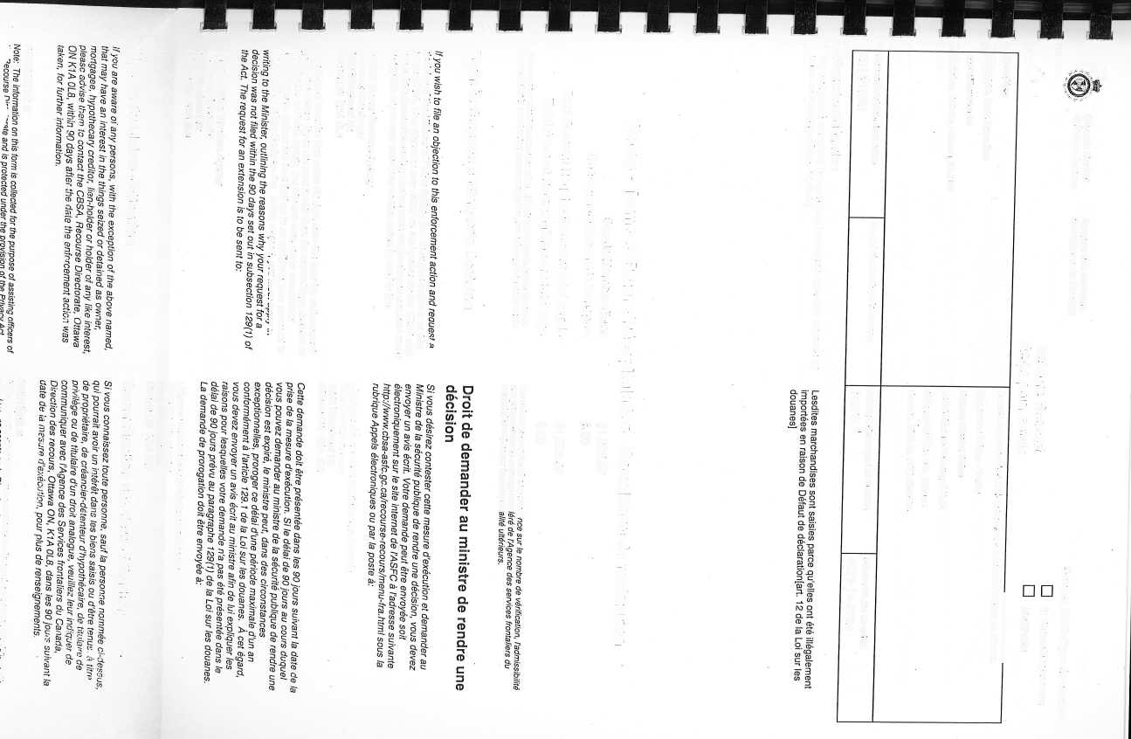

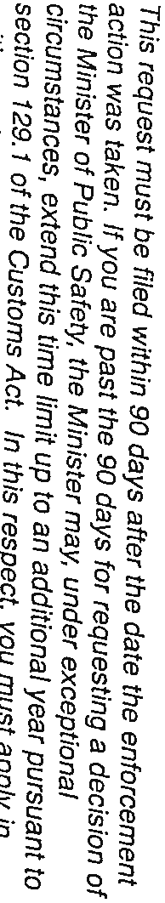


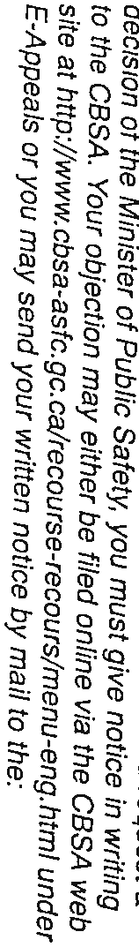

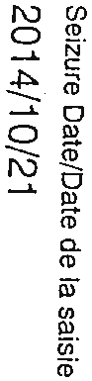



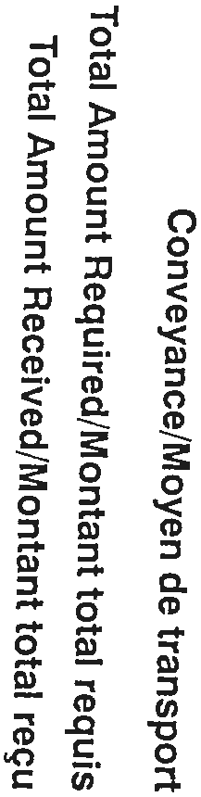






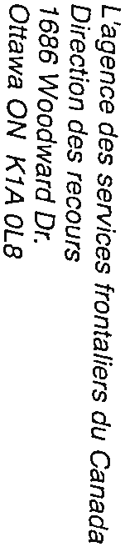
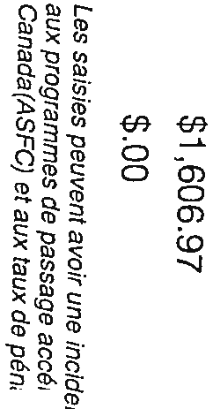
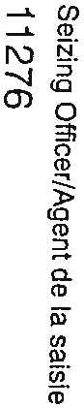
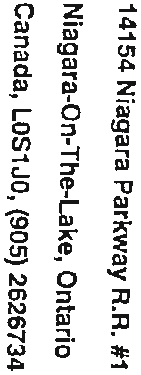


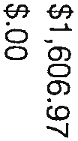
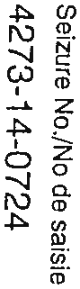


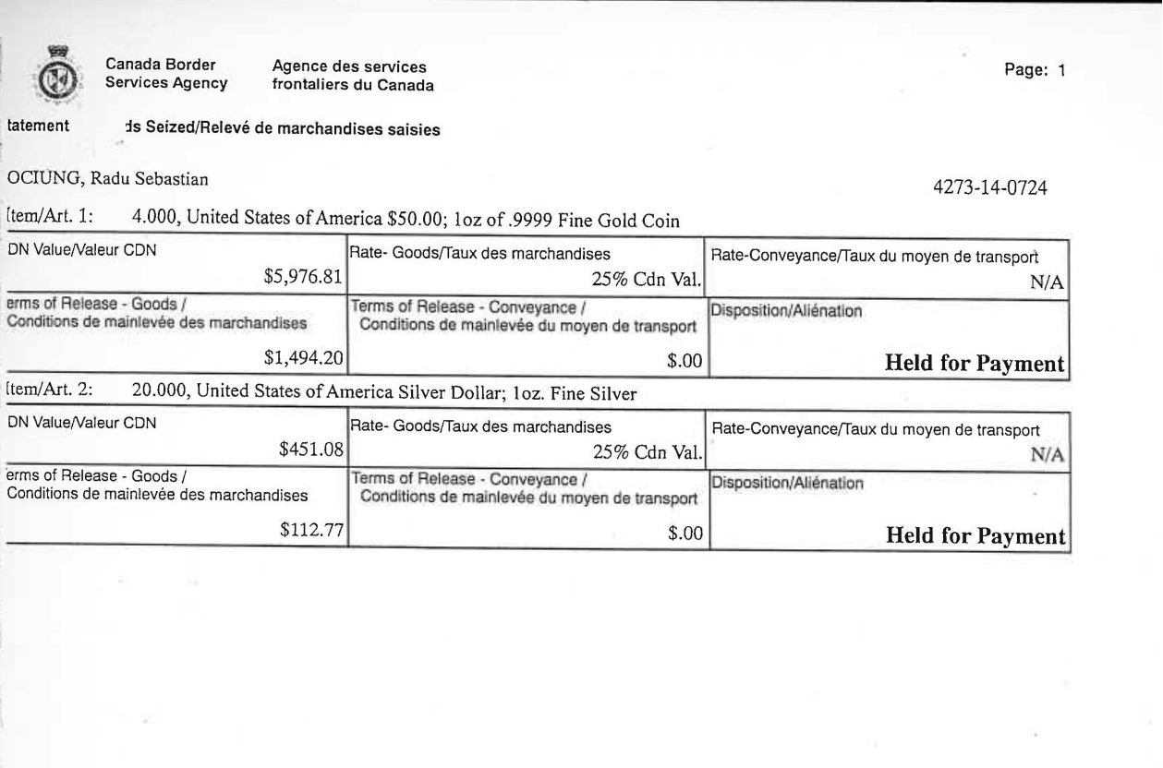
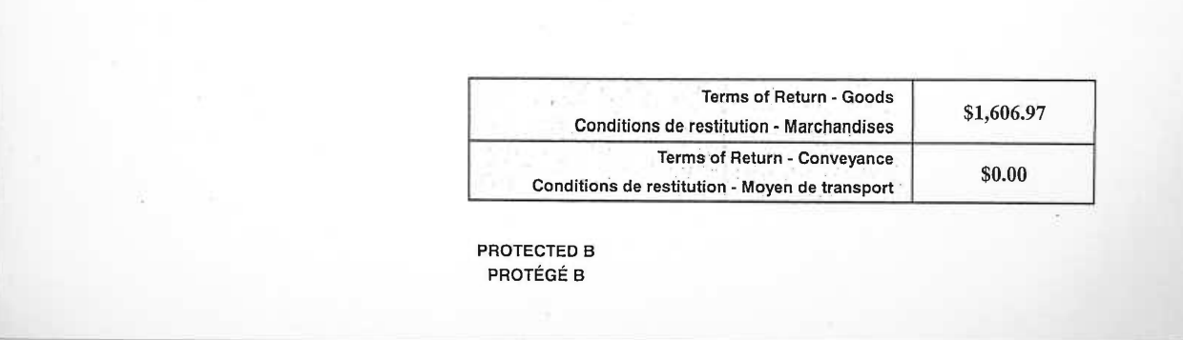

Online rating for gold coins
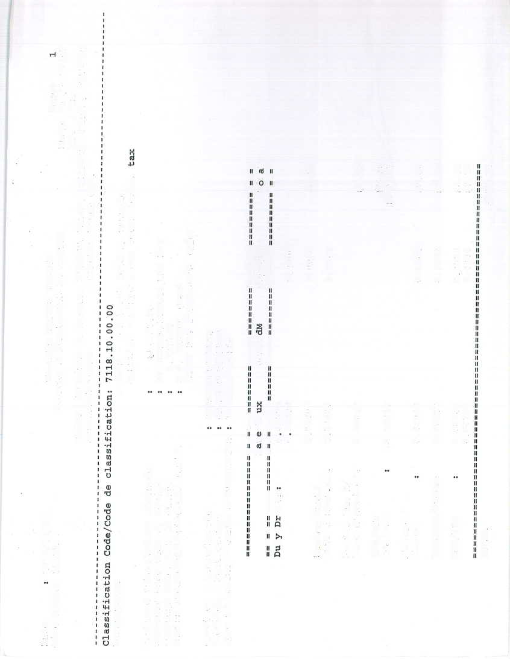
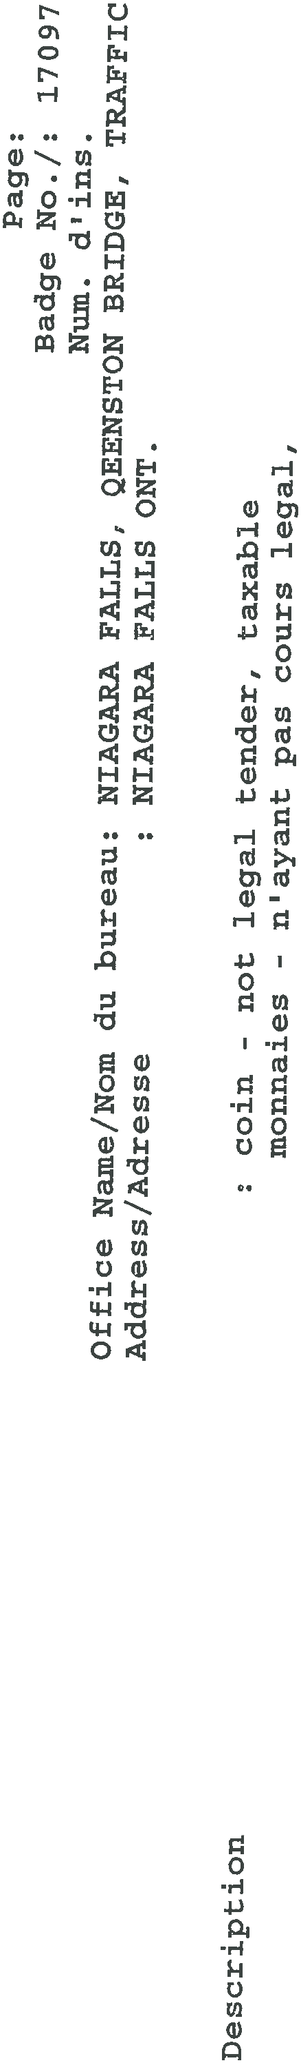
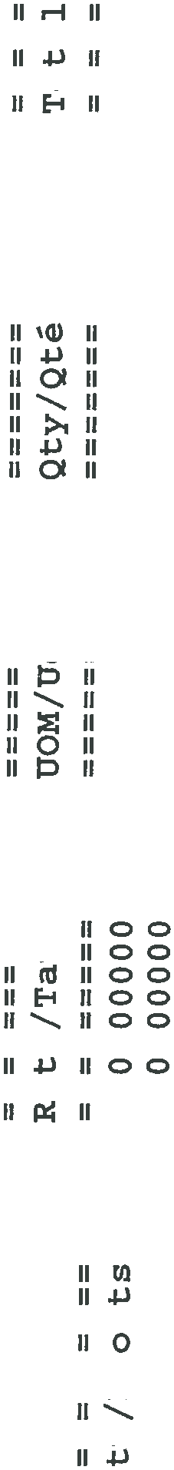





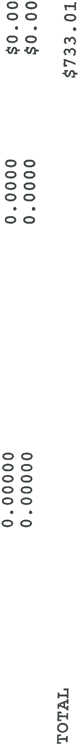
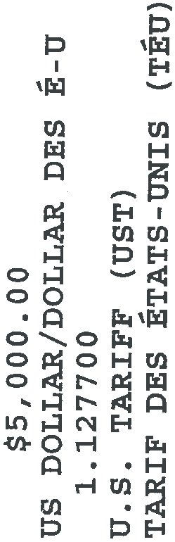














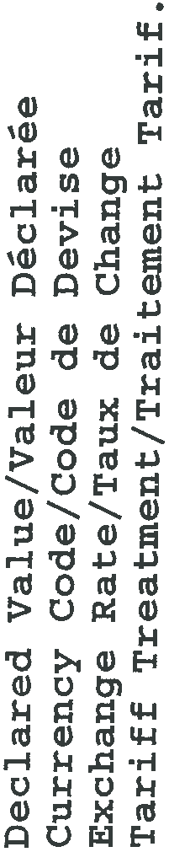




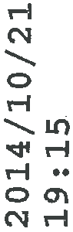





Minister's Decision
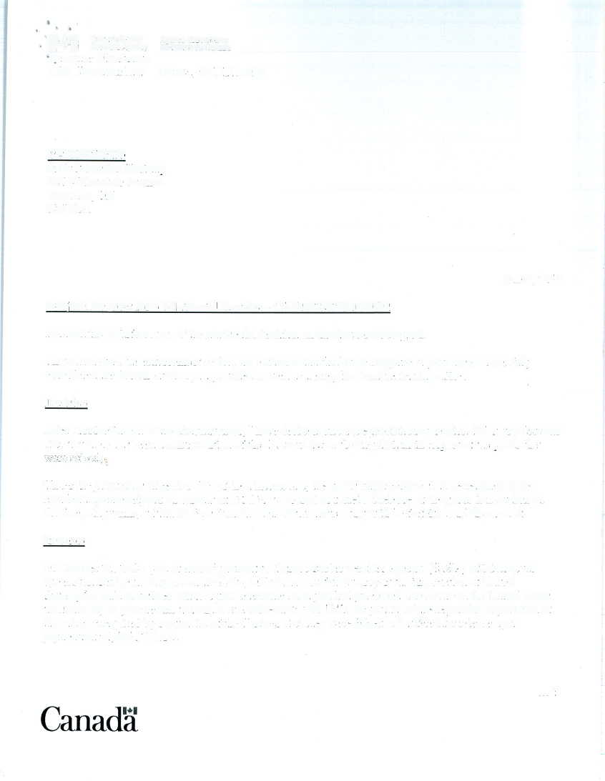


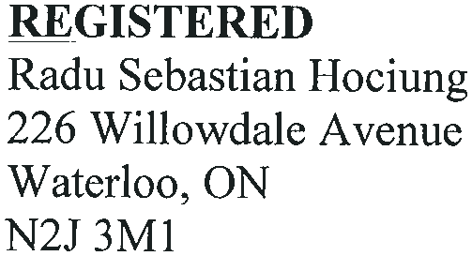



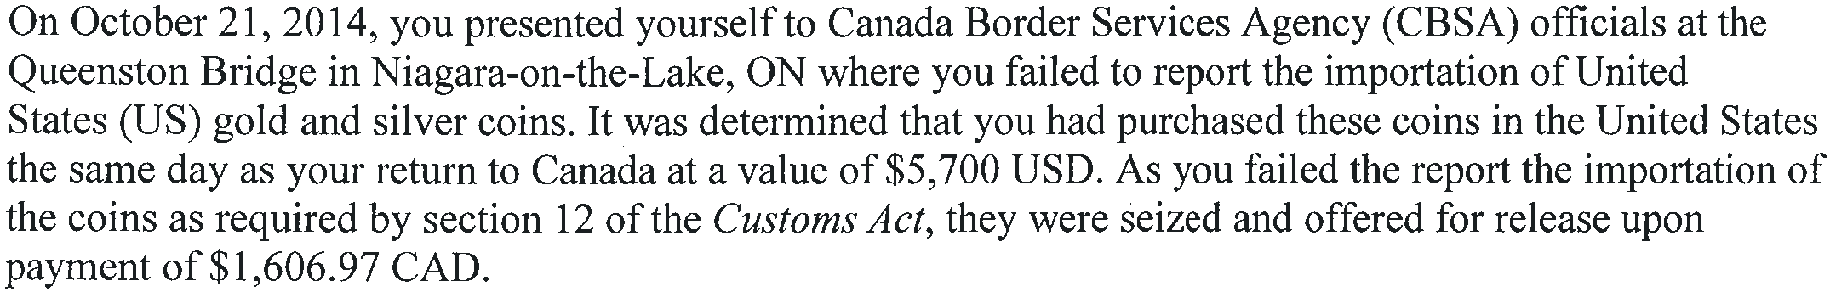

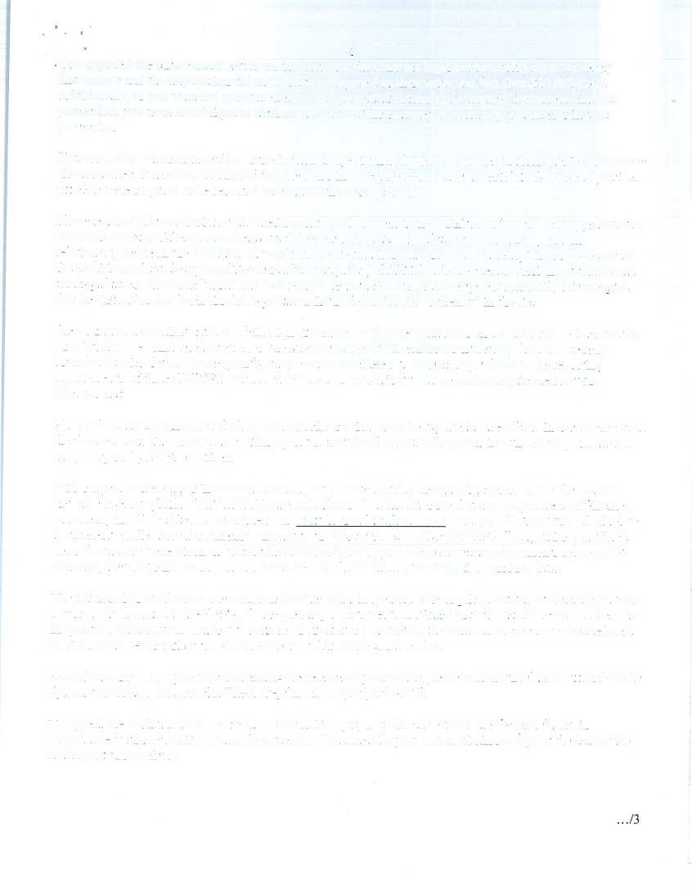
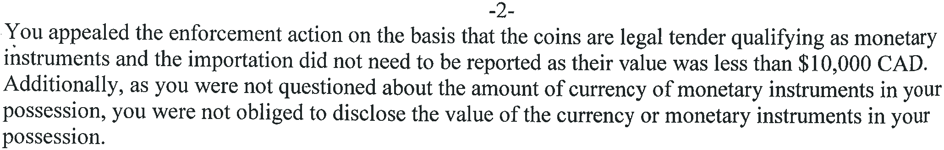
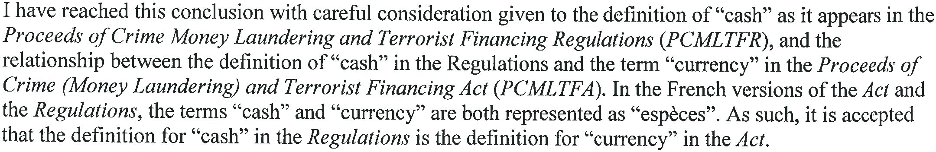
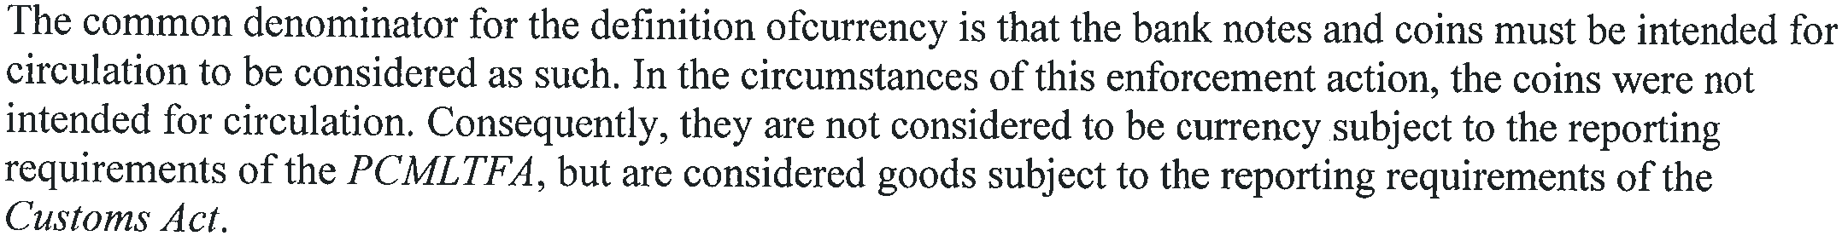
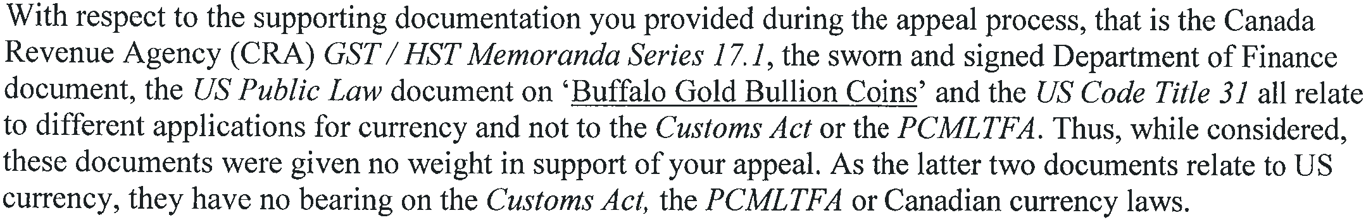
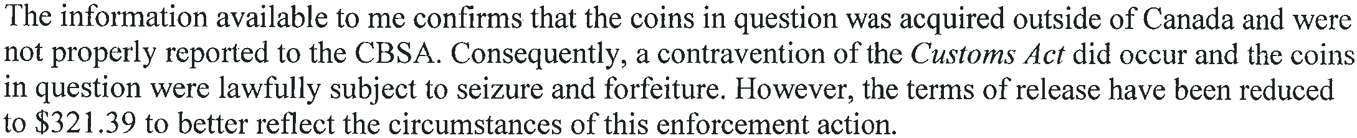
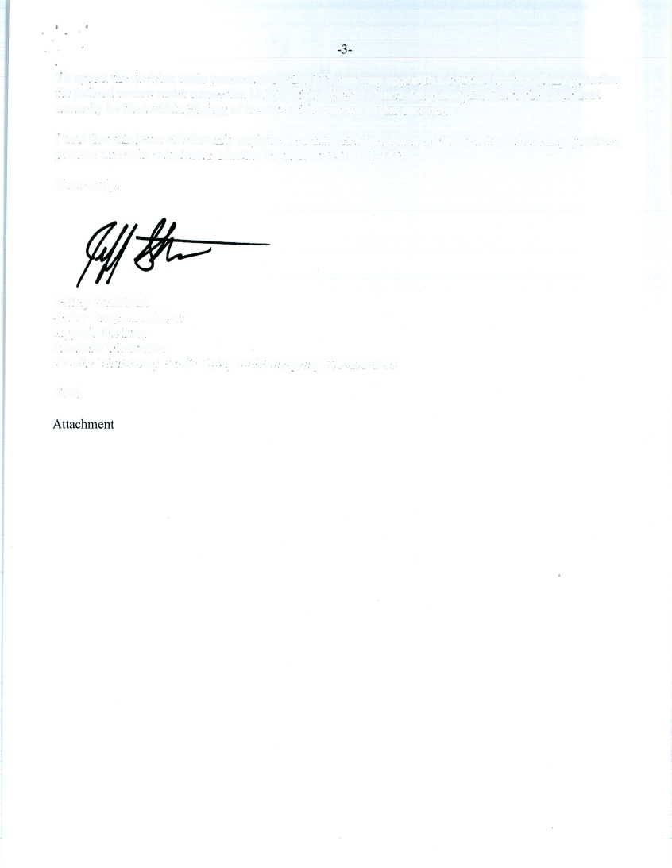

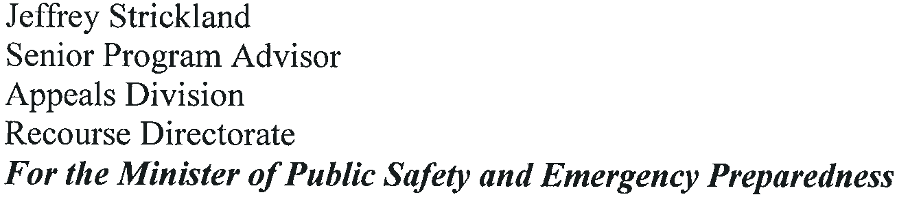


Excise Tax Act sections 50(1)(a), 50(1)(b) and 51

Tax Imposed

Consumption or sales tax
- 50 (1) There shall be imposed, levied and collected a consumption or sales tax at the rate prescribed in subsection (1.1) on the sale price or on the volume sold of all goods
  - (a) produced or manufactured in Canada
    - (i) payable, in any case other than a case mentioned in subparagraph (ii) or (iii), by the producer or manufacturer at the time when the goods are delivered to the purchaser or at the time when the property in the goods passes, whichever is the earlier,
    - (ii) payable, in a case where the contract for the sale of the goods, including a hire-purchase contract and any other contract under which property in the goods passes on satisfaction of a condition, provides that the sale price or other consideration shall be paid to the manufacturer or producer by instalments (whether the contract provides that the goods are to be delivered or property in the goods is to pass before or after payment of any or all instalments), by the producer or manufacturer at the time each of the instalments becomes payable in accordance with the terms of the contract, and
    - (iii) payable, in a case where the goods are for use by the producer or manufacturer thereof, by the producer or manufacturer at the time the goods are appropriated for use;
  - (b) imported into Canada, payable in accordance with the provisions of the Customs Act by the importer, owner or other person liable to pay duties under that Act;
  - (c) sold by a licensed wholesaler, payable by him at the time of delivery to the purchaser, and the tax shall be computed
    - (i) on the duty paid value of the goods, if they were imported by the licensed wholesaler, or
    - (ii) on the price for which the goods were purchased by the licensed wholesaler, if they were not imported by him, which price shall include the amount of the excise duties on goods sold in bond; or
  - (d) retained by a licensed wholesaler for his own use or for rental by him to others, payable by the licensed wholesaler at the time the goods are put to his own use or first rented to others, and the tax shall be computed
    - (i) on the aggregate of the duty paid value of the goods and the amount of any taxes payable on the goods under section 27, if they were imported by the licensed wholesaler, or
    - (ii) on the aggregate of the price paid by the licensed wholesaler for the goods, the amount of any excise duties payable on the goods if sold in bond and the amount of any taxes payable on the goods under section 27, if they were not imported by the licensed wholesaler.

Marginal note:

Marginal note:

Goods exempted
- 51 (1) The tax imposed by section 50 does not apply to the sale or importation of the goods mentioned in Schedule III, other than those goods mentioned in Part XIII of that Schedule that are sold to or imported by persons exempt from consumption or sales tax under subsection 54(2).

Excise Tax Act Schedule III Part XI

PART XI
Miscellaneous
- 1 Articles and materials purchased or imported by a government of a country designated by the Governor in Council pursuant to heading No. 98.10 of Schedule I to the Customs Tariff, or purchased or imported by a Canadian government agency on behalf of such a government, for the construction, maintenance or operation of military or defence establishments in Canada and not intended for resale, gift or other disposition except as may be authorized by the Minister of National Revenue.
- 2 Baler twine and materials for use exclusively in the manufacture thereof.
- 3 British and Canadian coins; foreign gold coin.
- 4 Coin of any metal, of authorized weight and design, issued for use as currency under the authority of the government of any country.

[ ... ]

Excise Tax Act, section 123(1) definitions

New Housing Rebate

Definitions
- 121 (1) In this section,

[...]

financial instrument means
- (a) a debt security,
- (b) an equity security,
- (c) an insurance policy,
- (d) an interest in a partnership, a trust or the estate of a deceased individual, or any right in respect of such an interest,
- (e) a precious metal,
- (f) an option or a contract for the future supply of a commodity, where the option or contract is traded on a recognized commodity exchange,
- (g) a prescribed instrument,
- (h) a guarantee, an acceptance or an indemnity in respect of anything described in paragraph (a), (b), (d), (e) or (g), or
- (i) an option or a contract for the future supply of money or anything described in any of paragraphs (a) to (h); (effet financier)

[...]

precious metal means a bar, ingot, coin or wafer that is composed of gold, silver or platinum and that is refined to a purity level of at least
- (a) 99.5% in the case of gold and platinum, and
- (b) 99.9% in the case of silver; (métal précieux)

Marginal note:

Canada Revenue Agency Memo 17.1 (Definition of “Financial Instrument”)
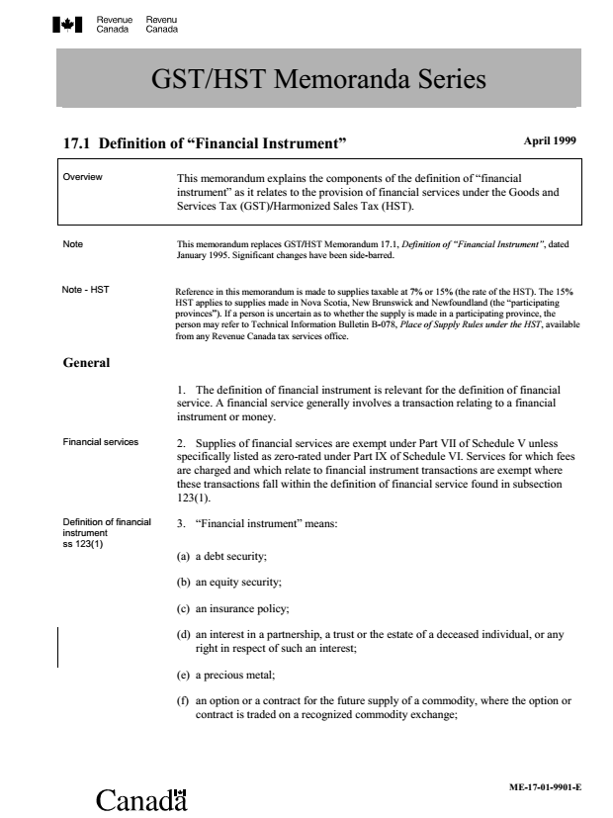
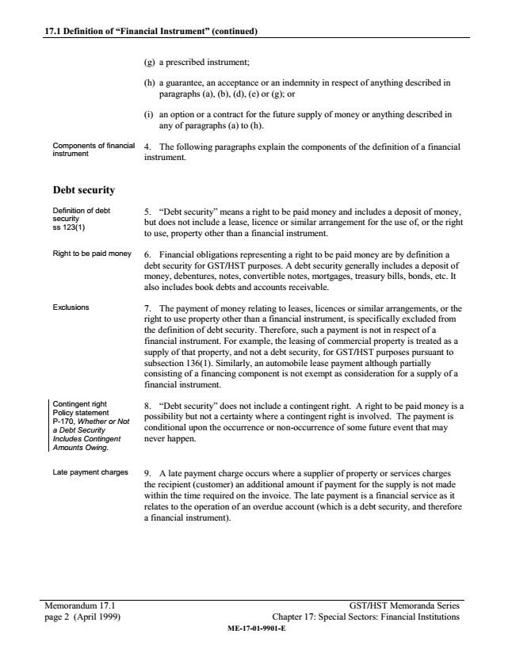
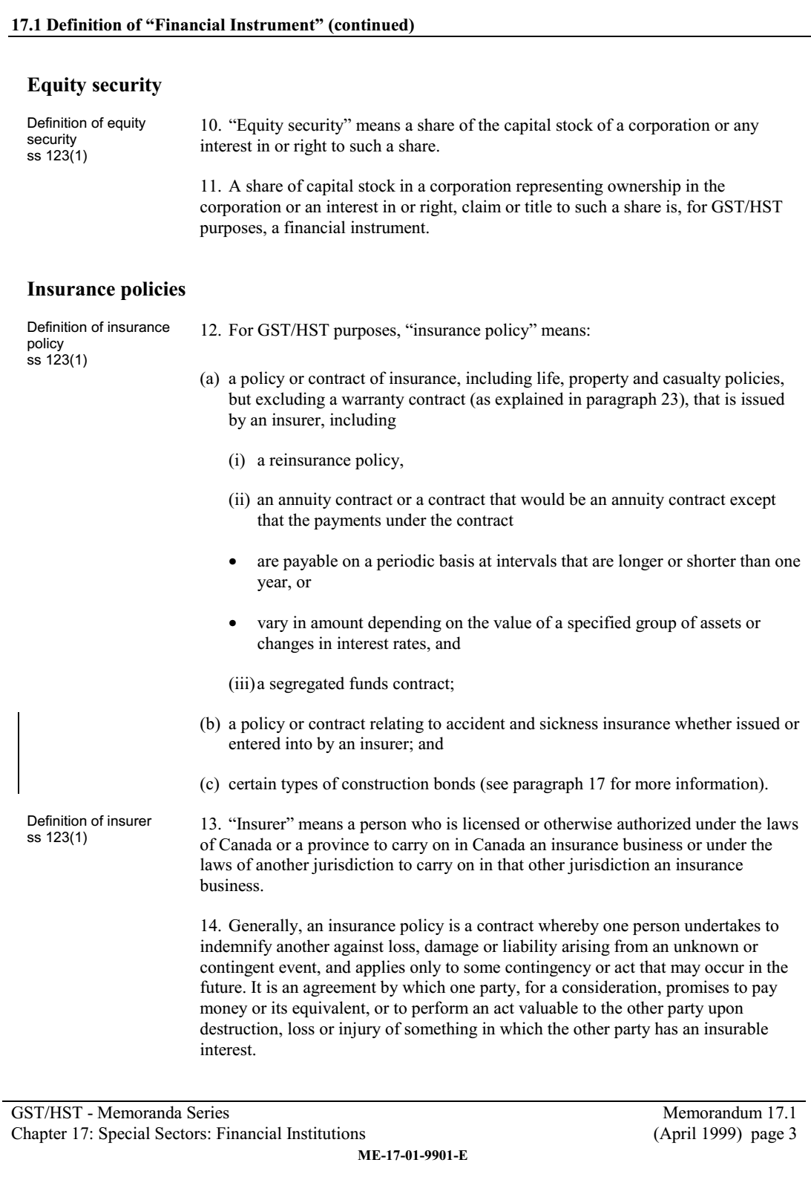
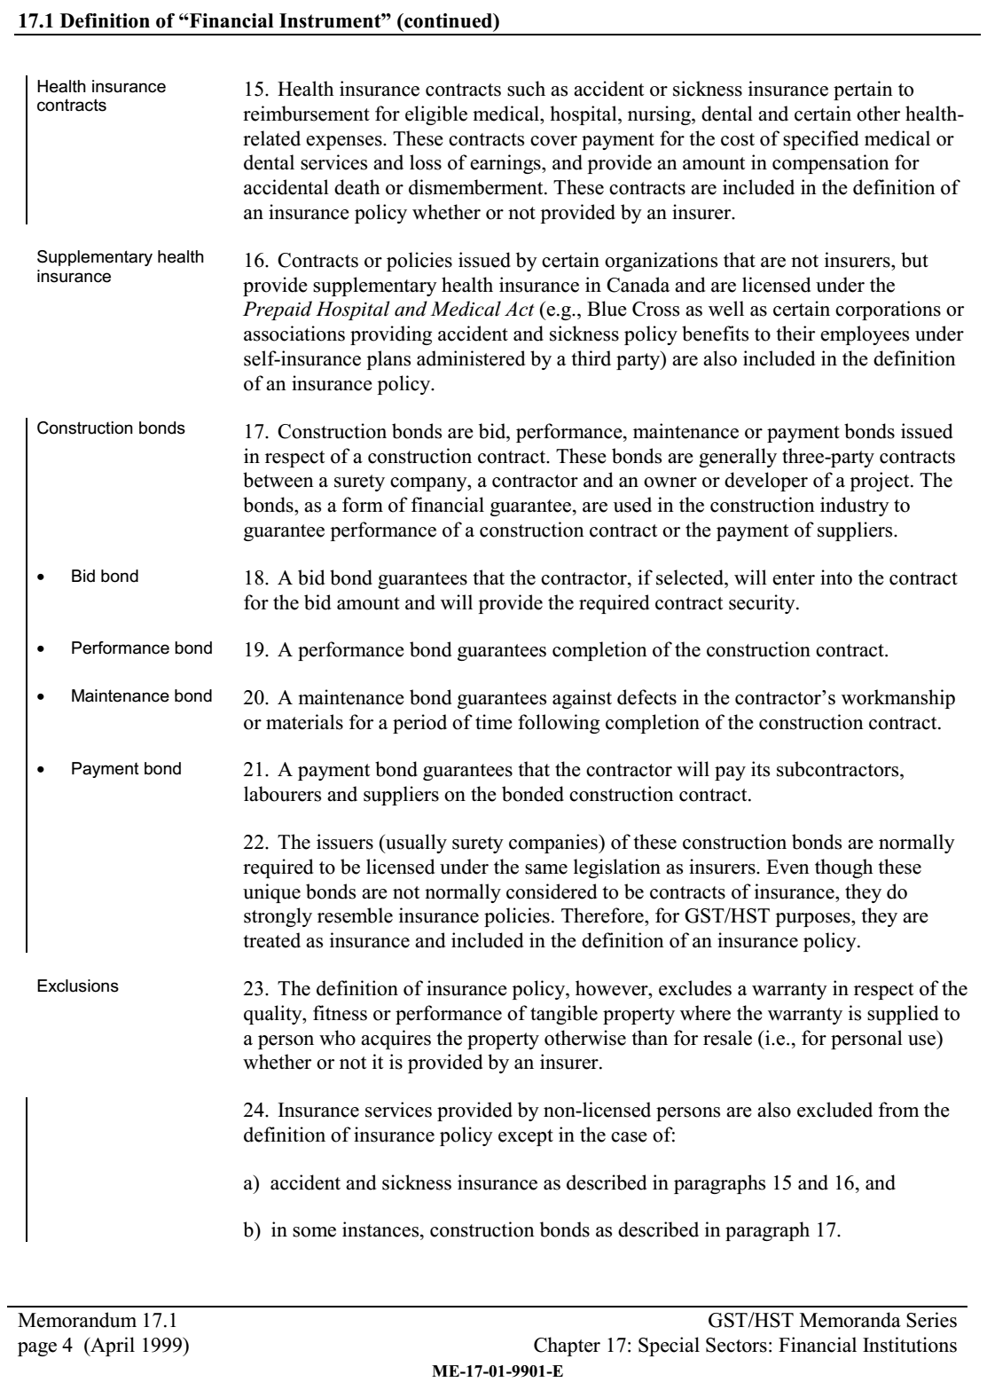
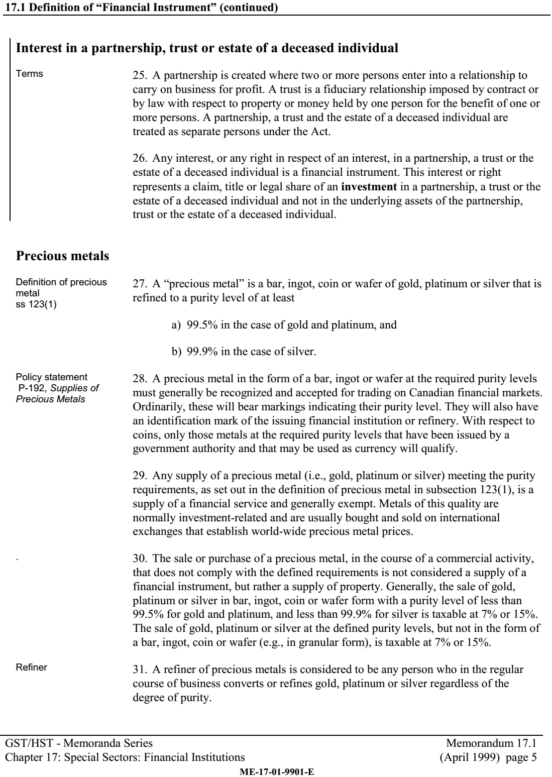
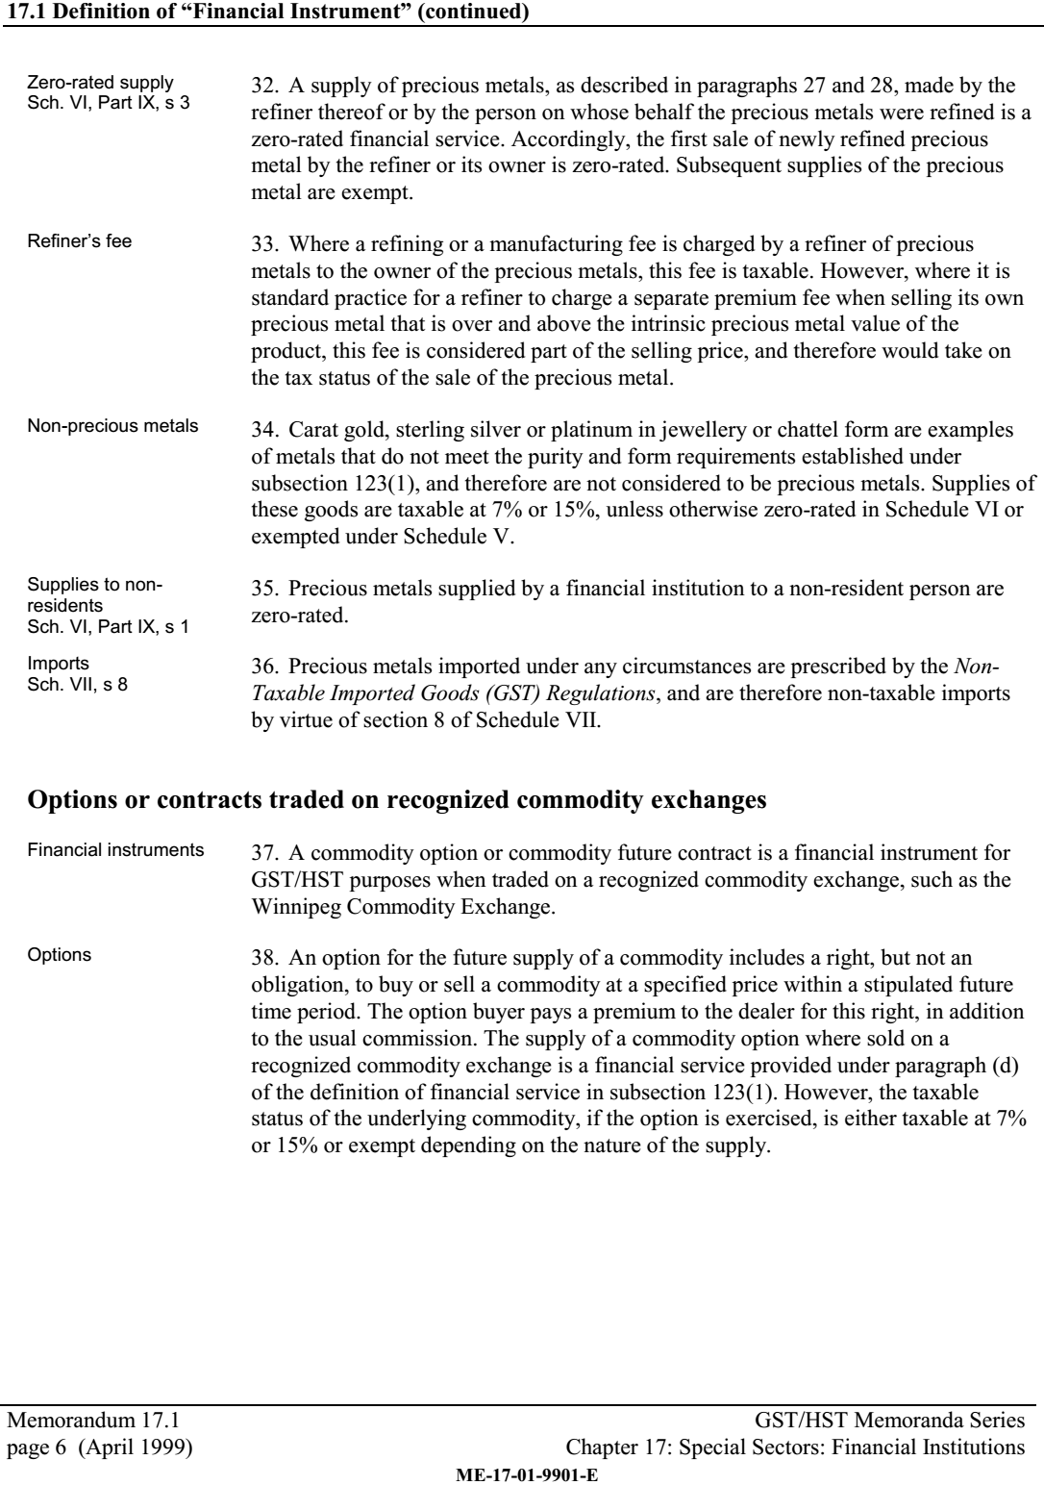
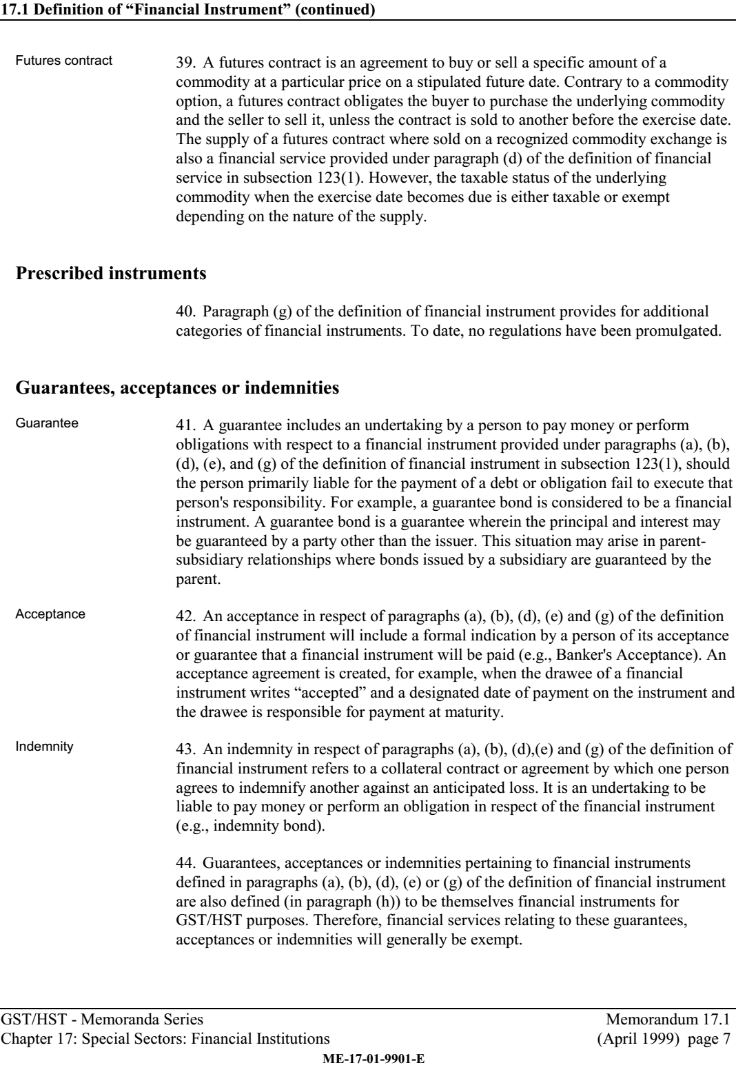
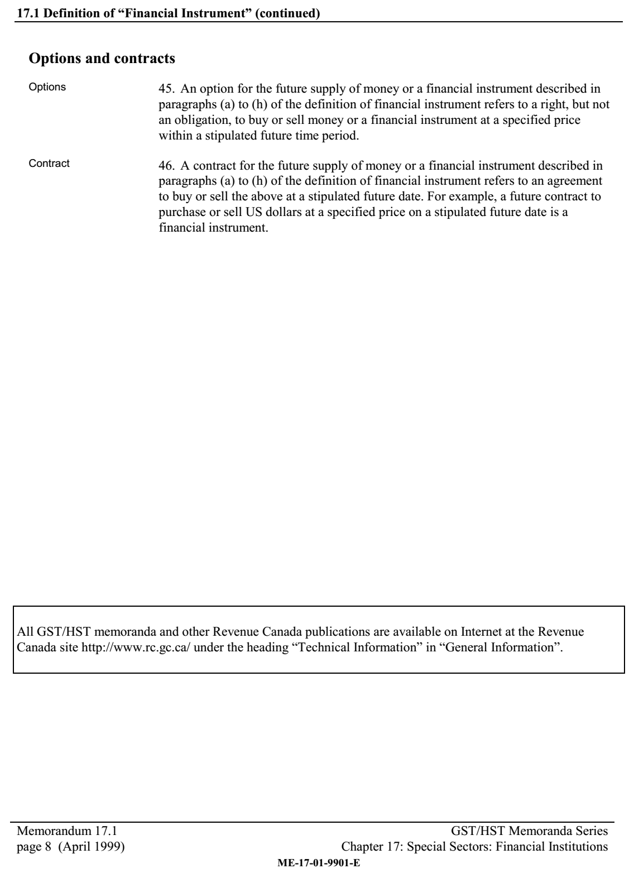

Non-Taxable Imported Goods (GST/HST) Regulations s3(a)

Prescribed Goods and Circumstances

3 For the purposes of section 8 of Schedule VII to the Act, the following goods and circumstances are prescribed:
- (a) precious metals imported under any circumstances;
- (b) unwrought silver, gold or platinum, waste and scrap of precious metal or of metal clad with precious metal, and concentrates of silver, gold or platinum, where imported for the purpose of being refined into precious metals;

[...]

Currency Act, s.7-8, 11, 15, 17, 21

Current Coins

Current coins
- 7 (1) A coin is current for the amount of its denomination in the currency of Canada if it was issued under the authority of
  - (a) the Royal Canadian Mint Act; or
  - (b) the Crown in any province of Canada before it became part of Canada and if the coin was, immediately before October 15, 1952, current and legal tender in Canada.

Defaced coins not current

(2) No coin that is bent, mutilated or defaced, or that has been reduced in weight otherwise than by abrasion through ordinary use, shall pass current.
- R.S., 1985, c. C-52, s. 7;
- 1999, c. 4, s. 11.

Legal Tender

Legal tender
- 8 (1) Subject to this section, a tender of payment of money is a legal tender if it is made
  - (a) in coins that are current under section 7; and
  - (b) in notes issued by the Bank of Canada pursuant to the Bank of Canada Act intended for circulation in Canada.

Limitation

(2) A payment in coins referred to in subsection (1) is a legal tender for no more than the following amounts for the following denominations of coins:
  - (a) forty dollars if the denomination is two dollars or greater but does not exceed ten dollars;
  - (b) twenty-five dollars if the denomination is one dollar;
  - (c) ten dollars if the denomination is ten cents or greater but less than one dollar;
  - (d) five dollars if the denomination is five cents; and
  - (e) twenty-five cents if the denomination is one cent.

Coins of denominations greater than ten dollars

(2.1) In the case of coins of a denomination greater than ten dollars, a payment referred to in subsection (1) may consist of not more than one coin, and the payment is a legal tender for no more than the value of a single coin of that denomination.

Different amounts payable on the same day

(3) For the purposes of subsections (2) and (2.1), where more than one amount is payable by one person to another on the same day under one or more obligations, the total of those amounts is deemed to be one amount due and payable on that day.

Melting Coins

Melting down coins
- 11 (1) No person shall, except in accordance with a licence granted by the Minister, melt down, break up or use otherwise than as currency any coin that is current and legal tender in Canada.

Offence and punishment

(2) Every person who contravenes subsection (1) or any condition attached to a licence referred to in that subsection is liable on summary conviction to a fine not exceeding two hundred and fifty dollars or to imprisonment for a term not exceeding twelve months or to both, and, in addition to any fine or imprisonment imposed, the court may order that the articles by means of or in relation to which the offence was committed be forfeited to Her Majesty.

[...]

Valuation of gold, etc.

15 Notwithstanding any other law, where any law of Canada or any treaty, convention, contract or agreement to which Canada is a party makes reference to
- (a) a currency of a country other than Canada,
- (b) a unit of account that is defined in terms of currencies of two or more countries,
- (c) gold, or
- (d) a combination of any of the things mentioned in paragraphs (a) to (c),

the Governor in Council may make regulations specifying, or specifying the means or method of ascertaining, determining or calculating, the equivalent dollar value of that currency, unit of account, gold or combination thereof.

[...]

PART II

Exchange Fund Account

Exchange Fund Account continued

17 The special account in the name of the Minister known as the Exchange Fund Account, established to aid in the control and protection of the external value of the monetary unit of Canada, is continued and all assets acquired and held by or on behalf of the Minister in the Exchange Fund Account continue to be so held.

Policy
- 17.1 (1) The Minister may establish a policy concerning the investment of the assets held in the Exchange Fund Account, including concerning the acquisition of assets to be held in the Exchange Fund Account, based on principles that a person of ordinary prudence would apply in dealing with the property of others.

Non-delegation of power

(2) The Minister may not delegate the power to establish the policy.

Statutory Instruments Act

(3) The Statutory Instruments Act does not apply to the policy.
- 2005, c. 30, s. 113.

Power to acquire, sell, etc.
- 17.2 (1) The Minister may acquire or borrow assets to be held in the Exchange Fund Account, and sell or lend those assets, in order to carry out the policy.

Financial transactions

(2) The Minister may carry out any transaction of a financial nature concerning assets held in the Exchange Fund Account that is in accordance with the policy.

Agents and mandataries

(3) The Minister may appoint agents and mandataries to perform services concerning the Exchange Fund Account.

Delegation in writing

(4) The Minister may delegate the powers set out in subsections (1) to (3) only in writing.
- 2005, c. 30, s. 113.

Crediting of Account

17.3 All amounts received by the Minister from transactions carried out under subsections 17.2(1) and (2) shall be credited to the Exchange Fund Account.
- 2005, c. 30, s. 113.

Contents of report

(2) The report referred to in subsection (1) shall include
  - (a) a summary of the policy established under subsection 17.1(1);
  - (b) the objectives of the Exchange Fund Account for that fiscal year, and a statement of whether those objectives have been met;
  - (c) the objectives of the Exchange Fund Account for the current fiscal year;
  - (d) the financial statements of the Exchange Fund Account; and
  - (e) a list of the agents and mandataries appointed by the Minister under subsection 17.2(3).

Currency Act, s.17 (2002-12-31 to 2005-12-29)

Exchange Fund Account continued
- 17 (1) The special account in the name of the Minister, known as the Exchange Fund Account, established pursuant to The Exchange Fund Act, chapter 60 of the Statutes of Canada, 1935, to aid in the control and protection of the external value of the monetary unit of Canada and continued by The Foreign Exchange Control Act, chapter 53 of the Statutes of Canada, 1946, is further continued, and all currency, deposits, securities and gold acquired and held by or on behalf of the Minister for the Exchange Fund Account shall continue to be so held.

Acquisitions

(2) The Minister may, with assets held by or on behalf of the Minister for the Exchange Fund Account, acquire or cause to be acquired
  - (a) currencies designated by the Minister;
  - (b) units of account designated by the Minister;
  - (c) gold;
  - (d) deposits that are
    - (i) denominated in those currencies or units of account or in gold, and
    - (ii) held with the Bank of Canada or any other financial institution inside or outside Canada designated by the Minister; and
  - (e) securities or notes that are denominated in those currencies or units of account or in gold and are issued or guaranteed by the Government of Canada or by such
    - (i) government of another country,
    - (ii) agency or institution of the Government of Canada or of the government of another country,
    - (iii) official international financial organization, or
    - (iv) institution

as is designated by the Minister.

Publication in Canada Gazette

(2.1) Within sixty days after making a designation under subsection (2), the Minister shall cause to be published in the Canada Gazette the name of the currency or unit of account designated or the criteria used by the Minister in making the designation under subparagraph (2)(d)(ii) or paragraph (2)(e).

Dealing in assets

(3) The Minister or an agent on behalf of the Minister may sell, lend, borrow or otherwise deal in currencies, units of account, gold, deposits or securities or notes described in subsection (2), on any terms and conditions that the Minister thinks fit, and may, for that purpose,
  - (a) enter into and participate in
    - (i) futures, forward, option, repurchase and reverse repurchase agreements, and
    - (ii) derivative or associated instruments or products

relating to those currencies, units of account, gold, deposits or securities or notes;
  - (b) accept any of those currencies, units of account, gold, deposits or securities or notes as security for any loan or undertaking; and
  - (c) give undertakings and give as security for the performance of the undertakings any assets held by or on behalf of the Minister for the Exchange Fund Account.

Publication in Canada Gazette

(3.1) Within sixty days after the Minister appoints an agent under subsection (3) or a derivative or associated instrument or product is entered into or participated in under subparagraph (3)(a)(ii), the minister shall cause to be published in the Canada Gazette the name of the agent or a description of the derivative or associated instrument or product.

Crediting of Account

(4) There shall be credited to the Exchange Fund Account
  - (a) the proceeds, earnings and interest from all transactions pursuant to subsection (3);
  - (b) all amounts received by the Minister on the maturity of any deposits and securities and notes held by or on behalf of the Minister for the Account; and
  - (c) all earnings and interest from the currencies, units of account, gold, deposits and securities and notes held by or on behalf of the Minister for the Account.

Royal Canadian Mint Act

United States Title 31
- Include sections 5112(a), (e), (h), (q) (Denominations, specifications and design of coins)
- Include section 5111(d) melting penalties

[...]

(e) Notwithstanding any other provision of law, the Secretary shall mint and issue, in qualities and
quantities that the Secretary determines are sufficient to meet public demand, coins which—
(1) are 40.6 millimeters in diameter and weigh 31.103 grams;
(2) contain .999 fine silver;
(3) have a design—
(A) symbolic of Liberty on the obverse side; and
(B) of an eagle on the reverse side;
(4) have inscriptions of the year of minting or issuance, and the words “Liberty”, “In God We
Trust”, “United States of America”, “1 Oz. Fine Silver”, “E Pluribus Unum”, and “One Dollar”;
and
(5) have reeded edges.
(f) Silver Coins.—
(1) Sale price.— The Secretary shall sell the coins minted under subsection (e) to the public at a
price equal to the market value of the bullion at the time of sale, plus the cost of minting, marketing,
and distributing such coins (including labor, materials, dies, use of machinery, and promotional
and overhead expenses).
(2) Bulk sales.— The Secretary shall make bulk sales of the coins minted under subsection (e)
at a reasonable discount.
(3) Numismatic items.— For purposes of section 5132 (a)(1) of this title, all coins minted under
subsection (e) shall be considered to be numismatic items.
(g) For purposes of section 5132 (a)(1) of this title, all coins minted under subsection (e) of this section
shall be considered to be numismatic items.
(h) The coins issued under this title shall be legal tender as provided in section 5103 of this title.
[...]

§ 5111. Minting and issuing coins, medals, and numismatic items

[...]

(d)
(1) The Secretary may prohibit or limit the exportation, melting, or treatment of United States
coins when the Secretary decides the prohibition or limitation is necessary to protect the coinage
of the United States.
TITLE 31 - Section 5111 - Minting and issuing coins, medals, and numismatic items
NB: This unofficial compilation of the U.S. Code is current as of Jan. 4, 2012 (see http://www.law.cornell.edu/uscode/uscprint.html).
- 611 -
(2) A person knowingly violating an order or license issued or regulation prescribed under
paragraph (1) of this subsection, shall be fined not more than $10,000, imprisoned not more than
5 years, or both.
(3) Coins exported, melted, or treated in violation of an order or license issued or regulation
prescribed, and metal resulting from the melting or treatment, shall be forfeited to the United States
Government. The powers of the Secretary and the remedies available to enforce forfeitures are
those provided in part II of subchapter C of chapter 75 of the Internal Revenue Code of 1954 1
(26 U.S.C. 7321 et seq.).
[...]

§ 5112. Denominations, specifications, and design of coins
(a) The Secretary of the Treasury may mint and issue only the following coins:
(1) a dollar coin that is 1.043 inches in diameter.
(2) a half dollar coin that is 1.205 inches in diameter and weighs 11.34 grams.
(3) a quarter dollar coin that is 0.955 inch in diameter and weighs 5.67 grams.
(4) a dime coin that is 0.705 inch in diameter and weighs 2.268 grams.
(5) a 5-cent coin that is 0.835 inch in diameter and weighs 5 grams.
(6) except as provided under subsection (c) of this section, a one-cent coin that is 0.75 inch in
diameter and weighs 3.11 grams.
(7) A fifty dollar gold coin that is 32.7 millimeters in diameter, weighs 33.931 grams, and contains
one troy ounce of fine gold.
(8) A twenty-five dollar gold coin that is 27.0 millimeters in diameter, weighs 16.966 grams, and
contains one-half troy ounce of fine gold.
(9) A ten dollar gold coin that is 22.0 millimeters in diameter, weighs 8.483 grams, and contains
one-fourth troy ounce of fine gold.
(10) A five dollar gold coin that is 16.5 millimeters in diameter, weighs 3.393 grams, and contains
one-tenth troy ounce of fine gold.
(11) A $50 gold coin that is of an appropriate size and thickness, as determined by the Secretary,
weighs 1 ounce, and contains 99.99 percent pure gold.
(12) A $25 coin of an appropriate size and thickness, as determined by the Secretary, that weighs
1 troy ounce and contains .9995 fine palladium.
[...]

[...]

(e) Notwithstanding any other provision of law, the Secretary shall mint and issue, in qualities and
quantities that the Secretary determines are sufficient to meet public demand, coins which—
(1) are 40.6 millimeters in diameter and weigh 31.103 grams;
(2) contain .999 fine silver;
(3) have a design—
(A) symbolic of Liberty on the obverse side; and
(B) of an eagle on the reverse side;
(4) have inscriptions of the year of minting or issuance, and the words “Liberty”, “In God We
Trust”, “United States of America”, “1 Oz. Fine Silver”, “E Pluribus Unum”, and “One Dollar”;
and
(5) have reeded edges.
(f) Silver Coins.—
(1) Sale price.— The Secretary shall sell the coins minted under subsection (e) to the public at a
price equal to the market value of the bullion at the time of sale, plus the cost of minting, marketing,
and distributing such coins (including labor, materials, dies, use of machinery, and promotional
and overhead expenses).
(2) Bulk sales.— The Secretary shall make bulk sales of the coins minted under subsection (e)
at a reasonable discount.
(3) Numismatic items.— For purposes of section 5132 (a)(1) of this title, all coins minted under
subsection (e) shall be considered to be numismatic items.
(g) For purposes of section 5132 (a)(1) of this title, all coins minted under subsection (e) of this section
shall be considered to be numismatic items.
(h) The coins issued under this title shall be legal tender as provided in section 5103 of this title.
[...]

(q) Gold Bullion Coins.—
(1) In general.— Not later than 6 months after the date of enactment of the Presidential $1 Coin
Act of 2005, the Secretary shall commence striking and issuing for sale such number of $50 gold
bullion and proof coins as the Secretary may determine to be appropriate, in such quantities, as the
Secretary, in the Secretary’s discretion, may prescribe.
(2) Initial design.—
(A) In general.— Except as provided under subparagraph (B), the obverse and reverse of the
gold bullion coins struck under this subsection during the first year of issuance shall bear the
original designs by James Earle Fraser, which appear on the 5-cent coin commonly referred
to as the “Buffalo nickel” or the “1913 Type 1”.
(B) Variations.— The coins referred to in subparagraph (A) shall—
(i) have inscriptions of the weight of the coin and the nominal denomination of the coin
incused in that portion of the design on the reverse of the coin commonly known as the
“grassy mound”; and
(ii) bear such other inscriptions as the Secretary determines to be appropriate.
(3) Subsequent designs.— After the 1-year period described to in paragraph (2), the Secretary
may—
(A) after consulting with the Commission of Fine Arts, and subject to the review of the
Citizens Coinage Advisory Committee, change the design on the obverse or reverse of gold
bullion coins struck under this subsection; and
(B) change the maximum number of coins issued in any year.
(4) Source of gold bullion.—
(A) In general.— The Secretary shall acquire gold for the coins issued under this subsection
by purchase of gold mined from natural deposits in the United States, or in a territory or
possession of the United States, within 1 year after the month in which the ore from which
it is derived was mined.
(B) Price of gold.— The Secretary shall pay not more than the average world price for the
gold mined under subparagraph (A).
(5) Sale of coins.— Each gold bullion coin issued under this subsection shall be sold for an
amount the Secretary determines to be appropriate, but not less than the sum of—
(A) the market value of the bullion at the time of sale; and
(B) the cost of designing and issuing the coins, including labor, materials, dies, use of
machinery, overhead expenses, marketing, and shipping.
(6) Legal tender.— The coins minted under this title shall be legal tender, as provided in section
5103.
(7) Treatment as numismatic items.— For purposes of section 1 5134 and 5136, all coins
minted under this subsection shall be considered to be numismatic items.
(8) Protective covering.—
(A) In general.— Each bullion coin having a metallic content as described in subsection
(a)(11) and a design specified in paragraph (2) shall be sold in an inexpensive covering that
will protect the coin from damage due to ordinary handling or storage.

Criminal Code, s380, 467, 469

Fraud
- 380 (1) Every one who, by deceit, falsehood or other fraudulent means, whether or not it is a false pretence within the meaning of this Act, defrauds the public or any person, whether ascertained or not, of any property, money or valuable security or any service,
  - (a) is guilty of an indictable offence and liable to a term of imprisonment not exceeding fourteen years, where the subject-matter of the offence is a testamentary instrument or the value of the subject-matter of the offence exceeds five thousand dollars; or
  - (b) is guilty
    - (i) of an indictable offence and is liable to imprisonment for a term not exceeding two years, or
    - (ii) of an offence punishable on summary conviction,

where the value of the subject-matter of the offence does not exceed five thousand dollars.

[...]

Definitions
- 467.1 (1) The following definitions apply in this Act.

criminal organization means a group, however organized, that
  - (a) is composed of three or more persons in or outside Canada; and
  - (b) has as one of its main purposes or main activities the facilitation or commission of one or more serious offences that, if committed, would likely result in the direct or indirect receipt of a material benefit, including a financial benefit, by the group or by any of the persons who constitute the group.

It does not include a group of persons that forms randomly for the immediate commission of a single offence. (organisation criminelle)

serious offence means an indictable offence under this or any other Act of Parliament for which the maximum punishment is imprisonment for five years or more, or another offence that is prescribed by regulation. (infraction grave)

Facilitation

(2) For the purposes of this section, section 467.11 and 467.111, facilitation of an offence does not require knowledge of a particular offence the commission of which is facilitated, or that an offence actually be committed.

Commission of offence

(3) In this section and in sections 467.11 to 467.13, committing an offence means being a party to it or counselling any person to be a party to it.

Regulations

(4) The Governor in Council may make regulations prescribing offences that are included in the definition serious offence in subsection (1).

Participation in activities of criminal organization
- 467.11 (1) Every person who, for the purpose of enhancing the ability of a criminal organization to facilitate or commit an indictable offence under this or any other Act of Parliament, knowingly, by act or omission, participates in or contributes to any activity of the criminal organization is guilty of an indictable offence and liable to imprisonment for a term not exceeding five years.

Prosecution

(2) In a prosecution for an offence under subsection (1), it is not necessary for the prosecutor to prove that
  - (a) the criminal organization actually facilitated or committed an indictable offence;
  - (b) the participation or contribution of the accused actually enhanced the ability of the criminal organization to facilitate or commit an indictable offence;
  - (c) the accused knew the specific nature of any indictable offence that may have been facilitated or committed by the criminal organization; or
  - (d) the accused knew the identity of any of the persons who constitute the criminal organization.

Factors

(3) In determining whether an accused participates in or contributes to any activity of a criminal organization, the Court may consider, among other factors, whether the accused
  - (a) uses a name, word, symbol or other representation that identifies, or is associated with, the criminal organization;
  - (b) frequently associates with any of the persons who constitute the criminal organization;
  - (c) receives any benefit from the criminal organization; or
  - (d) repeatedly engages in activities at the instruction of any of the persons who constitute the criminal organization.

CBC article on the retiring of the $1000 banknote.

Originally from: http://www.cbc.ca/news/business/bank-of-canada-kills-1000-bill-1.235393

National Post Article “The hunt for Canada's $1000 bills”

Originally from http://news.nationalpost.com/news/canada/the-hunt-for-canadas-1000-bills-there-are-nearly-a-million-left-most-in-the-hands-of-criminal-elites

Officer Debski Narrative Report

Evidence taken by officer Debski, photos, photocopies

Discovery of the Defendant, written answers part 1

Plaintiff Oral Discovery Examination

CBSA Customs Officer's Manual, PCMLTFA procedures.
- includes Part 2, Chapter 2, para 121, re: CBSA filtering info disclosed to FINTRAC
- Includes Part 2, Chapter 2, para 128, re: Counterfeit currency

CBSA Annual Report, 2014-2015

CBSA Memo 17-1-5

CBSA Memo D6-2-6 “Refund of Duties and Taxes on Non-commercial Importations”

Counterfeit gold coins ad from aliexpress.com

R. v. Nawaya BCSC-179965

Money Laundering and Terrorist Financing Trends in FINTRAC Cases Disclosed Between 2007 and 2011

CBSA Travellers Entry Processing System (TEPS) description

Customs Tariff
- Includes HS 490700 - Unused Postage, Revenue Stamps, Cheque Forms, Banknotes, Bond Certificates and The Like

Industry Canada HS490700 exports, imports

Canada Exchange Fund Account – Annual Report March 31, 2015

Bank Act, s. 600, 628

Canada Border Services Agency Act, s15.1

Financial Administration Act, s.150

Superintendent of Financial Institutions Consolidated Balance Sheet reporting requirements

Bombay Jewellers Ltd. v. The Queen, 1998 CanLII 320 (TCC)

Bank offerings of gold and silver

Central 1 Credit Union v. UM Financial Inc., 2012 ONSC 889

RCMP Charges in UM Financial Investigation

R. v. Kalair, 2015 ONSC 6784 motion

CBC Story about Khaled Nawaya arrest.

CBC report about Nawaya freed, gold returned.

Seizure Report of CBSA for Nawaya gold coins (October 6, 2009)

TODO: Subpoena CBSA for this doc before trial.

Narrative report of seizing officer in Nawaya case (October 6, 2009)

TODO: Subpoena this doc from CBSA before trial.

Canada Gazette – SOR/93-106 “Proclamation Authorizing the Issue and Prescribing the Composition, Dimensions and Designs of Certain Precious Metal Coins”

Canada Gazette SOR/2012-126 “Order Authorizing the Issue of Circulation Coins of Two Dollars, One Dollar and Twenty-five cents, Specifying Their Characteristics and Determining Their Design”

Ebay completed auction for 8 “war of 1812” quarters

Admasu v. Canada 2012 FC 451

Sellathurai v Canada (Minister of Public Safety and Emergency Preparedness), 2008 FCA 255

Sellathurai v. Canada (Public Safety and Emergency Preparedness), 2007 FC 208

Forum posts about CBSA's treatment of gold as 'goods'

Zakir Naik ban from Canada, UK, Bangladesh and India

Joanne Lepage assurances to Livingston Consulting

Seizure synopsys

Electronic Enforcement Appeal Form

Canada Revenue Agency, GST/HST Memo 17.1, “Definition of Financial Instruments”

CBSA (Ann Kendall) Letter to Radu Hociung dated November 3, 2014

Plaintiff letter to CBSA, November 10, 2014

Minister of Finance precious metals coins affidavit

US Public law 109-145 (Presidential $1 Coin Act of 2005)

November 19, 2014 advice by CBSA colleagues that gold is goods

December 11, 2014 Ann Kendall letter to the plaintiff

December 17, 2014, Notes on telephone conversation between Ms. Ann Kendall and the plaintiff.

The plaintiff's notes on the conversations

Jan 21, 2015 plaintiff letter to Recourse Directorate

January 21, 2015 Plaintiff letter to CBSA President.

Jan 29, 2015 John Dancause letter to Ann Kendall

March 9, 2015 letter from Martine Gagnon to the plaintiff.

March 17, 2015 letter from the plaintiff to Ms Gagnon

May 26, 2015 letter from Ms Gagnon to the plaintiff.

May 28, 2015 drafted Minister's Decision by Martine Gagnon

Case Synopsys

Canada Border Services Agency Act s12

US Mint Procedures to Qualify for Bulk Purchase of Gold and Platinum bullion Coins

(from https://www.usmint.gov/consumer/Gold-and-Platinum-APRequirements.pdf)

Email communications re Case Management Conference Mar 2, 2017

